The Manager,
HR Department,

Sub: Application for the Post of Biomedical Engineer.

Dear Sir/Maim,

I would like to take this opportunity to introduce myself and express my interest in being a part of your esteemed organization.

Being a dedicated, self-motivated and sincere individual, I look forwards to being a part of an organization that will give me an excellent working environment and a great potential for developing professionally as well as personally.

With this in mind, I have attached a brief outline of my educational and professional history for your review. Should you find my profile of interest I would be more than eager to meet with you to discuss any opportunity you may have within your organisation.

I am awaiting a favourable response.

Yours sincerely,

Nabeel

NABEEL PUTHENPEEDIKAKKAL

Cell: +919645392973, +916282617576
ppnabeel.pp@gmail.com

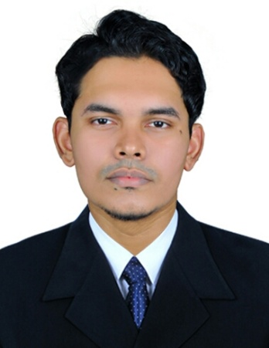

PROFESSIONAL SUMMARY
Professional Biomedical Engineer experienced in the management of healthcare technology providing solutions that help organizations deliver high quality patient care through timely accurate and cost-effective care. Ability to understand technical data and electrical schematics, trained to troubleshoot to component level. Accomplished with 5 years of experience in inspecting equipment on medical systems.

HIGHLIGHTS
- Medical equipment management plans
- Regulatory compliance
- Customer relations
- Performance assurance inspections
- Operation verification procedures
- Inventory management

EXPERIENCE
Biomedical Engineer
- Presently am working in Central Referral Hospital under Sikkim Manipal Institute of Medical Science, Gangtok, Sikkim. As Biomedical Engineer (2018 to till present)
- Have 4 years experience in Perform and coordinate scheduled maintenance on contracted medical equipment at Sevana Hospital & Research Centre, Pattambi, Palakkad (DST) Kerala, India.
- Repaired medical, Dental and clinical equipments are used as standby and maintained from this organization.

ACADAMIC QUALIFICATION
- Diploma in Biomedical Engineering (Technical Board Kerala) in Modern Group of Institute, Kollam, Kerala, India. 2007 - 2010.
- Plus Two in CHMHSS (Higher Secondary Board, Kerala) Kannur, Kerala, India. 2005 -2007
- SSLC in CHS (High School, Kerala board) Kannur, Kerala, India. 2005.

KEY SKILLS
- Hands on Experience with Operating System such as Windows, XP, etc.
- Proficient to use software’s like MS-Office, Excel.

PERSONAL DETAILS

Name : Nabeel Puthenpeedikakkal
Gender : Male
Age : 29
Marital Status : Married
Date of Birth : 25/12/1989
Nationality : Indian
Religion : Muslim
Languages Known : English, Hindi and Malayalam

Declaration
I hereby declare that all the information provided above is true and accurate to the best of my knowledge and belief.

NABEEL.PP

