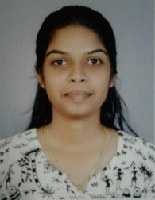
Mary Alin Manuel
Mail id : maryalinmanuel22@gmail.com Mob : 8281670558

Professional Summary
A hard working and committed individual who is able to work well as part of a team as well as under own initiative. Has excellent communication skills and able to cooperate with colleagues and customer in a professional manner .Trustworthy and reliable and able to follow instructions to maintain a high work output with great accuracy and efficiency.
Core Competencies

- Highly Motivated and Inspiring
- Smart appearance
- Punctual and Dedicated
- Sincere and Trustworthy

Professional Experiences

- Career Advisor in Santa Monica Study Abroad Pvt Ltd.
July 2017 to Oct 2018
Responsibilties :
- Help the students to choose their career and give them proper information regarding their needed requirements for their abroad studies plan.
- Get them the right course and college in the dream place .

- Communicative English Faculty
June 2016 to Feb 2017
Responsibilities :
- Help the student to improve their confidence and get rid of stage fear and to speak fluently.
Education
- MBA in Human Resource Management (MG University 2016)
- BSC Tourism and Hospitality Management (Madurai Kamaraj University 2014)
Training Experience
- 45 days training in Travel Masters India Corporation.Chennai.
- 45 days training in Thomas Cook.Calicut.
Computer Proficiency
All windows operating systems – MS Office.

