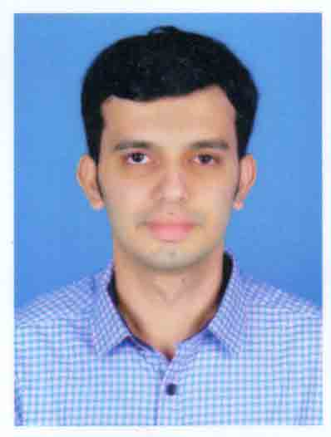

SREERAM.R.NAIR

+919645054111
Sreeramnair1993@gmail.com

Objective

- KNC License

- BSc Nursing
- PG Diploma in Emergency Medical Service
- BLS
- ACLS
- ITLS

Seeking a challenging position as a Registered Nurse, where I can fully utilize my practical and interpersonal skills to provide the maximum level of care and an environment that fosters my professional growth as well.

Professional License
KNC (KERALA NURSING COUNCIL) – KL04201603534

Educational Qualifications

- Bachelor Degree in Nursing (DR.M.G.R UNIVERSITY CHENNAI)
- EMS: PG diploma in Emergency Medical service (Aster mims kottakkal , )
- BLS : (Basic Life Support) Conducted by A.H.A (American Heart Association)
- ACLS:(Advanced Cardiac Life Support) Conducted by A.H.A (American Heart Association)
- ITLS : (International Trauma Care Life Support)

- Computer skills- Microsoft Office tools.

- Solid Experience in Emergency roomand Mobile ICU as Trauma care Nurse

WorkExperience
Employer: Aster MIMS (Malabar Institute of Medical Science Ltd),Hospital, kottakkal , kerala , India.

Designation: EMS Staff nurse& Mobile ICU Nurse.
Area of Experience:Emergency room and mobile ICU
Duration: August/16/ 2016 to February/18/2019

Contact

Mobile : +919645054111

E-mail: sreeramnair1993@gmail.com

Skills andCompetencies

- Participation in Cardiac Arrest Management according to ACLS protocolTriaging of patients according to Canadian acuity scale.
- Conducted AHA BLS & ACLS

- Disaster Management exercise (Internal and External) & Management of critically ill (priority I and II)

- Assisting in Endotracheal Intubation, Central Line, and Lumbar Puncture.
- Basic ECG interpretation (12 leads).
- Care to all trauma victims including poly trauma following RTA's, fall or assault.
- Acute burns, poisoning management & Disaster management.
- Emergency management of Cardiac Arrest, Stroke & Myocardial Infarction.
- Acute Respiratory Arrest Management.
- Mass casualty management
- Managed patients with various respiratory conditions such as exacerbation of COPD, Bronchial Asthma, ARDS, Pneumothorax and Hem thorax.
- Skill full in neonatal and paediatric IV cannulation.
- Skill full in managing paediatric code blue, poisoning and anaphylaxis.
- Administration of Thrombolytic for acute Stroke and Myocardial Infarction
- Skilful in effective usage of Non Invasive Ventilation.(BIPAP & CPAP)
- Familiar with Cardio Version, Defibrillation and Temporary Pacemaker
- Insertion of Nasogastric Tube and suctioning.
- Collection of blood samples for routine analysis &Arterial Blood Gas analysis.
- Central Venous pressure monitoring.
Equipments Handled

- Ventilators - NellcorPuritanBennette 840 & 740, Siemens Servo 900 & 300, Draggor
- Monitors – Multi-Para monitors from Philips, Spacelabs, Agilent & BP
- Defibrillators - Agilent Smart Biphasic, GE Cardioserv, Nihon KohdenCardiolife
- Syringe Pumps - Pilot, A2, F. TranseniusViace 0459
- BIPAP, CPAP - Resmed VPAP II , VPAP III
- ECG Machine – GE MAC 1200, MAC 500
- Centralized oxygen and suction devices.
- ABG analyser
Personal Details
Date of Birth: 15/07/1993
Declaration
Nationality : Indian
Marital Status : Single
Language Known: English, Hindi, Malayalam,Tamil
Passport NO : J3359887
Declaration
I hereby declare that all the details furnished above are true to the best of my knowledge and belief.

SREERAM.R.NAIR

