Curriculum vitaE

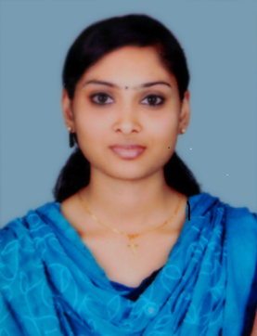

ANCY ALIYAS

MAMUTTATHIL HOUSE

MEENANGADI POST

CHENDAKUNI

WAYANAD. KERALA

Mob:9747075550

Email.ancyaliyas07@gmail.com

PERSONAL DETAILS:

Present address : Maliyekal house
Nettor .P.O
Maradu
Cochin - 682040
Permanent address : Mamuttathil house,
Meenangadi post
Chendakuni
Wayanad[Dist]
Kerala, India, Pin : 673591
Date of Birth : 17/05/1994
Sex : Female
Father name : M.P Alias
Nationality : Indian
Martial status : Married
Religion : Christian
Languages known : English,Malayalam,&Hindi

ACADEMIC QUALIFICATIONS:
Examination passed | Board/University  (Examination) | Year  of passing | Percentage of marks obtained
SSLC | Kerala Board of Public Examination | 2009 | 77%
PLUSTWO | Board of Higher Secondary, Kerala | 2011 | 78%
B.Com | Calicut University | 2014 | 83%
M.Com | Calicut University | 2016 | 70%

ADDITIONAL ACADAMIC QUALIFICATIONS:

During student period :1) Professional Diploma in Computerized Financial Accounting
:2) Diploma in Sales Tax Practice

WORK EXPERIENCE:

Period | Hospital | Designation | Department
04/10/2016 to 30/06/2018 | Soukya Indian Holistic Health Centre Pvt.Ltd. Bangalore | Executive Accountant | Accounts
23/07/2018 to 31/12/2018 | Defab In Style  Cochin | Accountant | Accounts

JOB DESCRIPTION:

- Drafting proper reports (Trading and Profit & Loss account , Balance Sheet, Cash Outflow and Inflow) and records
- Verifying that all accounting related records
- Maintaining Inventory System
- Auditing
- Perform Bookkeeping
- General Ledger Function
- Reconcile Vendor Balances
- Reconcile Bank Accounts
- Billing

REFERENCE:

Mr. Rajesh Kumar
Accounts Manager
C/O Soukya Indian Holistic Health Centre Pvt.Ltd.
Bangalore , Karnataka

OBJECTIVE:

Looking for an opportunity in a prestigious organization where I can express in Accounting.

DECLARATION

I do hereby declare that the above mentioned facts are true and correct to the best of my knowledge and belief.

Date : 06/03/2019 Ancy Aliyas

Place : Wayanad

