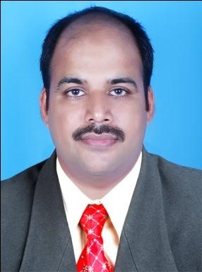
Angamaly
Ernakulam – 683581 | Email ID | : baijupaulm@gmail.com
Kerala | Mobile | : 9544906633

CURRICULUM VITAE

BAIJU PAUL
Manickathan House
Manjapra P.O.,

CAREER OBJECTIVE
A position in a result oriented firm seeking an ambitious career- conscious person where acquired skills and education will be utilized towards continuous growth and advancements.

EDUCATIONAL QUALIFICATION

- MSW (2005 -2007) (Medical Social Work) with 65 percent marks from Karpagam Arts and Science College, Coimbatore, Bharathiar University.
- Diploma in Hotel Management (2000 -2002), Foodcraft Institute, Kalamassery.
- B.Com (2000 – Commerce Batch) with 44 percent marks from Mahatma Gandhi University.
- Pre-Degree (1996 – 1st Group) with 40 percent marks from Sree Sankara College, Kalady, M.G. University.
- S.S.L.C (1994) with 68 percent marks Mar Augustine’s High School, Thuravoor.

TECHNICAL KNOWLEDGE
❖ MS Word, Power point, Excel, Tally

PROFESSIONAL EXPERIENCE
- Worked as Public Relation Officer in Aster DM Healthcare Ltd.
At Aster Capital Trivandrum and Aster Medcity Kochi, since 06th February, 2017 to 31st January 2019.
Key Responsibilities
  - Public Relation activities for Aster Capital Project Trivandrum and Aster Medcity Kochi.
  - Sanctioning different approvals from various authorities for Aster Medcity Hospital, Kochi.
  - Coordinating and providing Guest Relation service for the government and ministerial officials visiting hospital.

- Worked as Public Relation Officer at Little Flower Hospital and Research Centre, Angamaly from 11th February 2008 to 31st December 2016, (9 years)

➢ Responsibilities Handled
Coordinating Medico-legal Cases, Death and Birth Registration, Executive Medical Checkups, Guest relation, Medical Insurance, Medical Camps, Referral Marketing, Crisis Management – IP, OP and Emergency Department.

- Public Relation Officer cum Counselor from 05-06-2007 to 06-02-2008 at Ideal Mind Care Mental Health Hospital, Perumbavoor.

- Assistant Chef at Cochin Metro Hotel (P) Ltd. for the period of 2003 -
2005.

EXTRA CURRICULAR ACTIVITIES
- Has participated in competitions at the college level like Mime, Singing and Street Play
LINGUISTIC ABILITIES
- Can Speak : English, Malayalam, Hindi, Tamil
- Can Write : English, Hindi, Malayalam

PERSONAL DETAILS
Father’s Name | : M.V. Poulose
Date of birth | : 28/03/1979
Gender | : Male
Nationality | : Indian
Marital Status | : Married
Religion | : Christian
Hobbies: Reading Listening to Music, watching T.V., Playing cricket

REFERENCE
- Mr. Jayachandran M.V.
Government Relation Officer
Aster DM Healthcare Ltd.
Aster Medcity, Kochi.
Ph: + 91 -9656900751

- Mr. Anurag T V HR Manager
Aster DM Healthcare Ltd.
Kochi.
Ph: +91 -9656900720
DECLARATION

I, hereby declare that the above furnished information are true and correct to the best of my knowledge, information and belief.

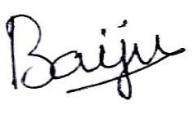
Place: Angamaly
Date:
BAIJU PAUL

