RESUME

SREELEKSHMI D S

Email: sreevava1994@gmail.com Mobile:8129913976,9959237201
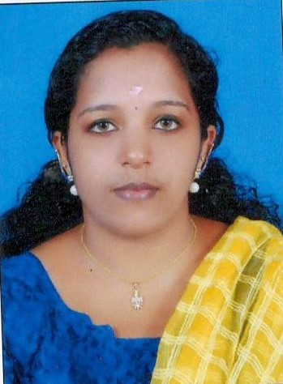
___________________________________________________________________
CAREER OBJECTIVE:

Seeking a position as a nurse in a reputed hospital where I can get learning environment along with using my skills for the profitability of the hospital and could serve the patients.

EDUCATIONAL QUALIFICATION:

2011-2015 : Bachelor of Science in Nursing
Vijaya College of Nursing Kottarakara, Kerala University of Health Science

2009-2011 : Higher secondary
Board of Higher Secondary Examinations Kerala

2008 – 2009 : SSLC

Board of Public Examinations Kerala

CAREER SUMMARY:

- A patient oriented and caring professional with excellent patience and remarkable organizing skills possesses 1 year experience as a nurse.

- Proved loyalty and knowledge of medical ethics.

- Proven record of reliability and responsibility.

- Possess special sensivity to meeting different needs in varied situations.

- Establish contacts with patients, family, staff and physicians.

RESPONSIBILITIES HANDLED:

- Caring the patient 24X7
- Handling Medical-surgical/ critical care, Emergency rooms, cardiac care and outpatient environments.
- Manage the admission and discharging of patients.
- Provide suggestions to family member and other staff on diseases.
- Maintain the patient charts.
- Provide training to the new recruiters.
- Performing simple and complex treatments.
- Handling injuries and illness, including administering medications, applying medical devices and administering specialized tests.
- Monitored quality assurance programs of patient care documentation.
- Performing discharge planning for patients.
- Preparing reports of patients care activities.
- Writing nursing orders.
- To identify patient care needs.
- Evaluate effectiveness of nursing practice.

TECHNICAL SKILLS:
- Use of internet for studying about hospital related issues and medical care
- Good experience in Microsoft Word and Excel.
SKILLS:
- Broad knowledge of interventions.
- Hard working and quick learning.
- Can manage the critical situations easily.
- Preadmission assessment and testing.
- Use of testing program flow charts.
- Problem solver.
- Highly self- directed.
CAREER HIGHLIGHTS:
- Participated training at Govt. RCC Trivandrum
- St. Geregorious Hospital, Cardiac centre, Parumala
- Govt. Mental Health Centre, Peroorkada, Trivandram.
- Life Line Super Specialty Hospital, Adoor.
- Holy Cross Hospital, Kottiyam, Kollam.
- Govt. Taluk headquarters Hospital, Kottarakara.
- I have 4 years training experience from Vijaya Hospital (200 bedded) with all specialty.
ACHIEVEMENTS:
- Provide excellent support to therapist at therapy time.
- Patient care upto 15 patients per section.
EMPLOYER:
- Working as Nurse in APOKOS REHABILITATION MULTY SPECIALITY HOSPITAL 2 YEARS AND 6 MONTH( branch of APOLLO, HYDERABAD 2016-2018)

HOBBIES:

- Reading novels
- Internet surfing.

PERSONAL DETAILS:

Name : Sreelakhmi D S

Father’s name : Devadas S

Date of birth : April 21, 1994

Gender : Female

Marital status : unmarried

Nationality : Indian

Religion : Hindhu

Languages known : Malayalam, English and telugu.

Mother tongue : Malayalam
Permanent address : sunitha bhavan, Adayamon (P.O)
Kilimanoor, Trivandrum Dist, Kerala. 695614

DECLARATION:

I hereby declare that the information furnished above is true and correct to best of knowledge and belief.

Place:

Date:
(SREELEKSHMI D S)

