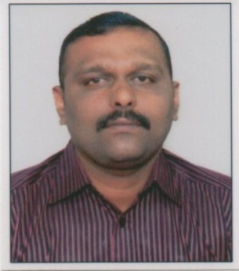

CURRICULUM VITATE

AKHILESH.M
MANIKANDA NIVAS
PERUNGOTTUKURISSI
PALAKKAD
KERALA – 678 574
PH; 04922 – 216291, 9539307644
akhileshmannil@gmail.com

OBJECTIVE
Seeking a position to utilize my skills and abilities in Customer Relation fields, office administrations, Sales and Marketing , and any other department that offers security and professional growth while being resourceful innovative and flexible.

PERSONAL SKILLS

Excellent verbal and written communication skills, ability to deal with people diplomatically, willingness to team, team facilitator.

ACADAMIC QUALIFICATIONS
- Diploma in Hotel Management from continental Institute, Kerala
- 10+2 from Board of Intermediate Education Andrapradesh
- S.S.L.C from Board of Secondary Education Andrapradesh
- Degree in B A English from Periyar University
- Certified course with PGDCA

EXPERIENCE
Presently working as Operations Manager in Dreams world Living Space Pvt Ltd . Utsavam Hotel Apartment Guruvayoor ( Hospitality wing ) at Guruvayoor, Thrissur, Kerala From February 2017 till date .
1.Worked as Asst Manager operations in Sky Line Foundations and Structures ( P ) Ltd. Premium service apartment Hotel Guruvayoor.( Hospitality wing ) and Resident Manager(Accounts and Administration) of SFS Temple Terrace project Guruvayoor from August 2013 to November 2017.
2.Worked as Operations Executive in Mayura Residency at Guruvayoor, Thrissur, Kerala From February 2013 to September 2013 .
3.Worked as Front Office Manager in Krishna Inn at Guruvayoor, Thrissur, Kerala From June 2011 to February 2013 .
4.Worked as Front Office Manager . in Nattika Beach Resort. Nattika at Thrissur Kerala from May 2010 May 2011.
5.Worked as Front office In Charge .in Al Jabal Al Akhdhar Hotel , Admin Manager in Sahara Hospitality At Muscat, Sultanate of Oman From May 2008 to February 2010. Albert Abela Group Of Companies LLC. ( Sahara Hospitality Co S A O G ) .
6.Worked as Front Office Asst. in Hotel Krishna Inn at Guruvayoor, Kerala from August 2005 to April 2008.
7.Worked as Front Office Asst. in Hotel Bhasuri Inn at Guruvayoor Kerala from 2005 January to 2005 July.
8.Successfully underwent training in Hotel Meghalaya at Vishakapatanam for six months from 15th March 2004 to 15th September 2004

COMPUTER PROFILE
- Programming Languages :C,C++, COBOL, Java, Visual Basic.
- Operating Systems : MS DOS, Windows XP.
- Database : Oracle
- Telephones : EPBAX systems

LANGUAGES KNOWN
English, Hindi, Telugu, Tamil Malayalam &Arabic

PERSONAL DETAILS
Age & Date of Birth : 37 Yrs, 02-06-1981
Community : Hindu, Nair
Nationality : Indian
Health : Good
In view my profile mentioned above I assure you that work by me is trustworthy and not for financial gain. I kindly request you to give an opportunity to serve your esteemed organization, I am confident of coming up to your expectations.

Place : Palakkad.
Date : AKHILESH .M

