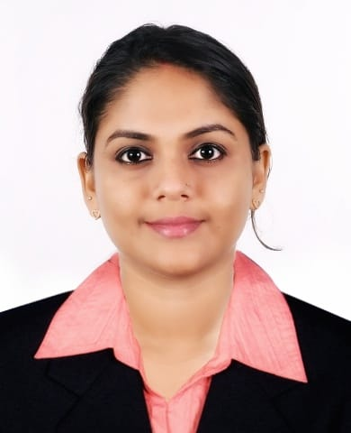
Parvathy E. M.
Human Resource Executive

Seeking a career to utilize my knowledge and personal skills to gain comprehensive understanding of a reputed organization so as to take responsibility and contribute significantly.

parvathyforme@gmail.com  9895146795 in. linkedin.com/in/Parvathy-Madhu
PROFESSIONAL SUMMARY
C.T.L Healthcare Pvt. Ltd. (September 2017- December 2018)
HR Manager and Coordinator

Enthusiastic and passionate human resource professional with one year of experience in CTL Healthcare Pvt Ltd. I have gained amble experience in managing various activities. Through my qualities, inherent skills and work experience I would like to enhance the status of the organization along with polishing my skills and abilities.

- Payroll Management
- Employees Joining Formalities
- Attendance Management
- Handling complete Recruitment lifecycle
- Exit Formalities
- Verifying Employee Allowance Claim
- Preparing Payment and Cash Vouchers
- Tally Updating- Cash/Bank
- Managing Travelling and Accommodation of Employees
- Maintaining Employee Files
- Preparing estimation of monthly budgets.

SKILLS
- Good organizational and time management skills
- A flexible approach to work
- Excellent coordination skills
- Willingness to learn
- Ability to deal with people diplomatically
- Team Player
- Enthusiastic & Passionate

ACADEMIC ACCOLADES
Course | Institute | Board/University | Percentage | Year
MBA | FISAT Business School | MG | 60 | 2017
B.com | SN College | Calicut | 62 | 2014
XII | Girls HSS | HSS | 82 | 2011
X | National HSS | SSLC | 82 | 2009

INTERNSHIP PERSONAL DETAILS PERSONAL DETAILS
HR Recruiter at Prakat Solutions Pvt Ltd Bangalore, April-May -2016 date of birth
PROJECTS
“A Study on The Effect of Organizational Factors and Job Satisfaction on Absenteeism of Employees, With Reference to KPL Oil Mils (P) Ltd, Irinjalakuda

EXTRA CURRICULAR ACTIVITES
- Attended International Seminar on Global Human Resource Development at CUSAT.
- School chairperson of students Association for the year 2009-2011 Govt Girls HSS Irinjalakuda
PERSONAL DETAILS
- Address : Aranakkal House, Nandipulam PO,Thrissur,Kerala.
- Date of birth : May 1st, 1993
- Languages known : English, Malayalam
- Marital status : Married.
- Interests &Hobbies : Movies, Reading, Travelling

DECLARATION
I hereby declare that all the above information is true to the best of my knowledge and is responsible for my candidature.

Parvathy E M
Date : 18 February 2019

