CURRICULAM VITEA

RIYA C.J.
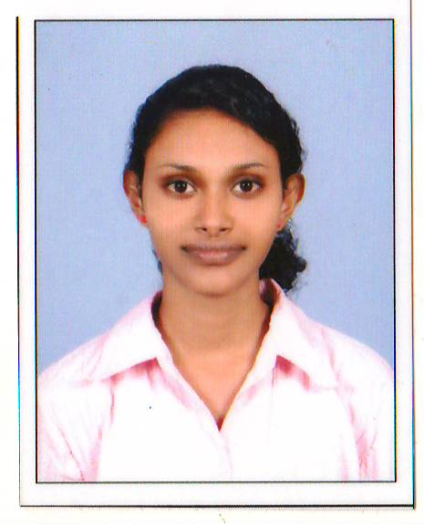
Chamminikodath House
South Chittoor P. O.
Kochi Pin -682027
Mobile No: 9961015628
Email Id:riyachammany@gmail.com

PERSONAL DETAILS

Father’s Name : Joseph C.C.
Date of Birth : 23-11-1994
Gender : Female
Marital Status : Single
Religion / Caste : Christian, Latin Catholic
Nationality : Indian
Languages Known : English, Malayalam & Hindi

ACCADAMEIC QUALIFICATION

- S.S.L.C
- Plus Two
- Bsc Mathematics

TECHNICAL KNOWLEDGE

- Diploma In Computerised Financial Management (DCFM)

WORK EXPERIENCE
- 6 months in Airtel 4G SIM Delivery section.
- 2 Years in Ziqitza Health Care Limited As CDC Executive.

PERSONAL SKILLS
- Ability To Work Independently And As A Team.
- Dedicated, Hardworking Nature And Adaptable To All Situations.

DECLARATION
I hereby declare that all the statements given above are true and complete to the best of my knowledge and belief.

Place: South Chittoor

Date: 1/3/2019 RIYA C.J.

