Curriculum vitae

OBJECTIVES:

Seeking a challenging position within a dynamic work environment, where my strong work background and my ability of work will be utilized well.

PROFILE:

- Self-motivated, innovative, good humored and enthusiastic experienced at working in any situation.

- Confident and poised in interactions with individuals at all levels.

- Excellent communication skills both written and oral.

- Skilled organizer, detailed analyzer caring and hardworking with the ability to consider all options before making a decision.

- High level of confidentiality.

- Equally effective in office administration and word processing support.

- Easily acclimate to new surroundings and is receptive to new ideas.

PERSONAL INFORMATION 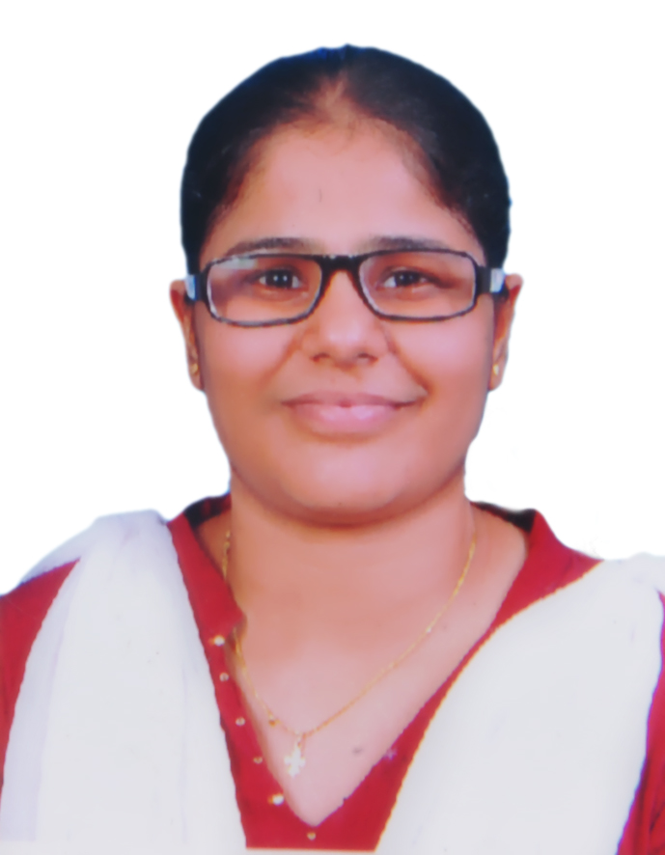

Name : Ms. STEPHY MARY MATHEW
Age & Date of Birth : 27 yrs, 13/1/1991
Sex : Female
Place of birth : Kozhencherry
Fathers name : Mr. MATHEW DANIEL
Nationality : Indian
Religion : Marthoma
Marital Status : Single
Profession : Bachelor of Science in nursing
Permanent address : Ms. STEPHY MARY MATHEW
Theverethu puthen parampil
kurichimuttom p.o,Edayaranmula
Pathanamthitta (dist.), kerala-689532
Phone No : +918466048541,9700169823
E-mail : stephymarymathew07@gmail.com

Language Known : English, Malayalam, Telugu.

Reference : Mrs. Haritha
Nursing superintendent
Care Hospitals
Gachibowli

ACADEMIC Qualification:

Sl No | Course | Duration | Name of the Institution | Year of Passing & remarks.
1 | S.S.L.C |  | A.M.M.H.S,Edayaranmula | March 2006
2 | Higher Secondary Course | 2 years | S.V.G.V.H.S.S,Kidaganoor | March 2009

PROFESSIONAL QUALIFICATION
sl No | Qualification | Name of the institution | Year of passing | %
1. | Bachelor of science in nursing. | SCS college of nursing  Mangalore | 2009-2013 | 60%

WORKING EXPERIENCE:-
Sl No | Name of Institution | Designation | Area of work | Duration
1. | Maxcure Super Specialty Hospital ,Hyderabad | Staff Nurse | Ward | 27/11/2014  To  07/11/2016
2 | Care Hospital, Gachibowli | Staff Nurse | Medical Surgical Ward | 01/02/2017  to  24/12/2018

EXECELLENT KNOWLEDGE OF BASIC NURSING FUNCTION AND SKILL TRAINED TO PERFORM THE FOLLOWING PROCEDURES / FUNCTIONS :
- Administration of Medicines
- Oxygen Therapy
- Ryles Tube Inspection & Gastric Lavage
- Transfusions and infusion Therapy
- Venus Puncture
- Urinary Catheterization (Male & Female)
- Bladder Irrigation
- Total Parental Nutrition
- ABG Sampling
- ECG
- Cardio Pulmonary Resuscitation
- Wound Dressing

FAMILIAR IN HANDLING THE FOLLOWING MACHINES AND EQUIPMENTS:

- ECG Machine
- Cardiac Monitors
- Pulse Oxymeters
- Glucometer
- Nebulization
- Oxygen flow meter
- Infusion and Syringe Pumps

HAVE ADEQUATE EXPERIENCE IN TAKING CARE OF PATIENT WITH

- Asthma, Bronchitis, ARDS & COPD
- RTA
- Epilepsy
- Sepsis
- DM, HTN
- Diabetic Keto-acidosis
- Liver diseases
- G.I.cases
- Appendectomy
- Hernia
- Post CABG

DETAILS OF WORK EXPERIANCE

- Receiving and Admission of Patient
- Data Collection
- Assessment of Vital Signs and intake/output monitoring
- Physical Examination and Diagnostic Evaluation
- Following Physician rounds and carryout the order prescribed
- Continuous Monitoring of Patients
- Assist patients in all levels with skillful nursing care and excellent knowledge in patient condition
- Provide adequate safety and psychological support to the patient
- Assessment and evaluation of nutritional needs of patients
- Transportation of Critically ill patients in ambulance
- Asepsis & infection control
- Health Education & personal hygiene
- Discharge and Follow up Care
- Attending weekly meetings with clients regarding patient condition and follow up
- Maintaining Records and Reports
- In service Education

Declaration

I do hereby declare that all the above information are true and correct to the
best of my knowledge and belief.

Place: Hyderabad Yours Faithfully,
Date: stephy mary mathew

