CURRICULUM VITAE
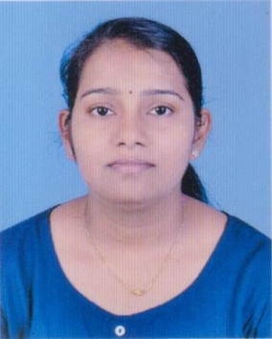
ELS MARY LAURANCE
Kaniyamattathil (H )
Kalayanthani P O
Alakodu
Thodupuzha
Ph : 7025678579,9961950240
Email : elsmaryl@gmail.com

CAREER OBJECTIVE
To obtain a challenging career in the health care field which will utilize my professional skills at its best and gives an opportunity for advancement and to continuously improve my skills for a prospective career pursuit

Educational Qualification
Course | Institution | Board/ University | Year of passing
SSLC | St. George’s Higher Secondary School Kalayanthani | Board of Public Examination | 2001
Plus Two | Govt. Higher Secondary school Poomala | Govt. of Kerala Board Higher Secondary Examination | 2003
PROFFESSIONAL QUALIFICATION
Diploma in General Nursing & Mid wifery | Lakshmi School of Nursing , Hyderabad Andhra Pradesh | Board Examination in GNM of Govt. of Andhra Pradesh | 01/08/2003  To  31/01/2006

EXPERIENCE DETAILS
18/09/20060 to 25/11/2009 : YASHODHA SUPER SPECIALTY
HOSPITAL SOMAJIGUDA, HYDERABAD
13/04/2010 to 10/09/2014 : BENGHAZI MEDICAL CENTER BENGHAZI
LIBYA
05/01/2014 to 05/06/2017: YASHFEEN CARDIAC HOSPITAL, NAVASARI,
GUJARAT

Personal Details
Name : ELS MARY LAURANCE
Date of Birth : 08/09/1985
Sex : Female
Father’s Name : Laurance
Religion : Christian, RC
Marital Status : Married
Nationality : Indian
Blood Group : O^{+ve}
Permanent Address: Kaniyamattathil (H)
Kalayanthani{P.O}
Alakodu
Thodupuzha
Idukki, Kerala
Contact No : 7025678579, 9961950240
E-mail : elsmaryl&gmail.com

Language Proficiency

Read & Write : English, Hindi, Malayalam

Speak : English, Hindi, Malayalam, Arabic, Telugu

Hobbies and interest
- Reading
- Listening Music

Declaration
I hereby declare that all the information furnished above is actually correct and hire to the best of my knowledge and belief.

Place: Vannappuram ELS MARY LAURANCE
Date:

