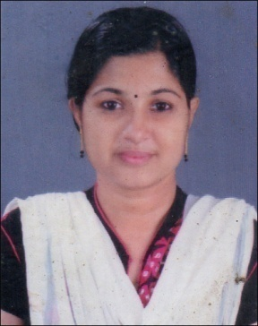
RESUME

DILNA ANEESH
VATTAPARAMBIL HOUSE
OLANAD
VARAPUZHA P.O
ERNAKULAM, KERALA-PIN 683517
MOB : 9497157323, 9847972339
Mail Id : aneeshvk2020@gmail.com
dilnaaneesh2017@gmail.com

PERSONAL DETAILS
Name : DILNA ANEESH
Date of Birth : 26-02-1994
Father’s Name : C.P Paul
Religion & Caste : Christian, Latin Catholic
Sex : Female
Marital Status : Married
Nationality : Indian
Language Known : Malayalam , English
EDUCATIONAL QULIFICATION
- S.S.L.C
- Diploma in Commercial Practice
- DCFA ( Diploma in Computerized Financial Accounting )
COMPUTER SKILL
- MS Office, tally, English & Malayalam Type writing
EXPERIENCE
- 1 year experience as a Office Staff (accounts Departmen )in Ashis Supermercatho, Ernakulam
- 1.5 year worked as accountant in Anns Communication, Ernakulam
- Presently working in INSIGNIA BIOMEDICAL, Kaloor, Ernakulam

DECLARATION
I do hereby declare that the particulars of information and facts stated herein above are true, correct and complete to the best of my knowledge and belief.
Place: Varapuzha
Date: DILNA ANEESH

