Stelin Sunny
BSc NURSE
Areas of interest: Medical ward, Casualty, Intensive care unit, Cardiac care unit, Operation Theatre
sunnystelin@gmail.com +91-7558039843

abc@gmail.com 0000000000

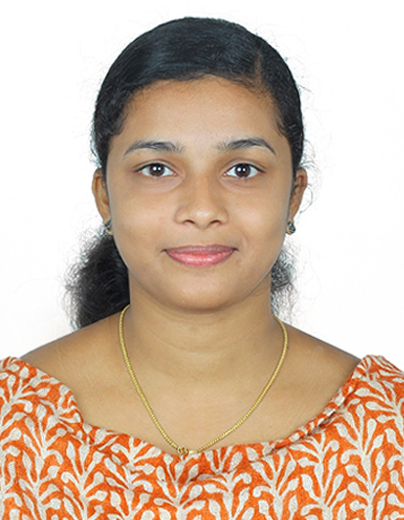
Career Objective

To provide superior clinical care to broad based patient populations and want to work with a hospital where my experience and knowledge may prove fruitful and worthwhile.
Education

BSc Nursing from Samaritan College of Nursing, Pazhanganad, Ernakulam, Kerala, affiliated to Kerala University, in 2016
Plus Two from St. Joseph GHS Chengal, Ernakulam in 2012
SSLC from S.N.D.P.H.S Neeleeswaram, Ernakulam in 2010

Work Experience

June 2018 - December 2018
Mar Augustine Golden Jubilee Hospital Mookkannur, Angamaly as Staff Nurse

March 2018 – May 2018
Samaritan Hospital, Pazhanganad, Ernakulam as Trainee Staff

Outcomes:
- Observing and recording patients’ behavior.
- Coordinating with physicians and other healthcare professionals for creating and evaluating customized care plans.
- Create harmonious environment to provide emotional and psychological support to the patients and their families.
- Maintaining reports of patients’ medical histories, and monitoring changes in their condition.
- Carrying out the requisite treatments and medications.
- Adhering with the protocols, norms, rules and regulations in order to maintain complete medical records.
- Maintaining hygienic and safe working environment in compliance with the healthcare procedures.
- Conducting research for improving the nursing practices and healthcare outcomes.
- Providing instant care during medical emergencies, like car accidents, burns, heart attacks and strokes.
- Providing necessary guidance on health maintenance and disease prevention.
- Keeping an eye on each and every aspect of patient care that includes physical activity plus proper diet.
- Preparing rooms, and decontaminating equipments and instruments.
- Preparing patients for examinations.
- Educating patients’ families about the disease and its treatment.
- Resolving patients’ problems and fulfilling their requirements by applying multifaceted team strategy.
- Interacting with the healthcare teams for maintaining harmonious relationships.

Personal Skills
- Polite and soft in nature
- Can manage the problems easily.
- Good decision maker.
- Loyal towards my work and duties.
IT Skills
- Proficient in MS Office

Personal Details

Father’s Name: Sunny A.D
Date of Birth: 30-09-1994
Languages Known: Malayalam & English
Gender: Female
Religion & Caste: Christian/RC
Marital Status: Single
Nationality: Indian
Address : Arackal House, Neeleeswaram P.O. Mundagamattom, Ernakulam, Kerala, PIN-683574

