Name: JIBIN JOSE
Address:
CHIRAKUZHIYIL (H)
MANGANAM P.O
KOTTAYAM
KERALA
Pin: 686018
Phone: +91-8907006097
Phone: +91-6238324154
Email Id: jibinjosec93@gmail.com

Facebook ID :
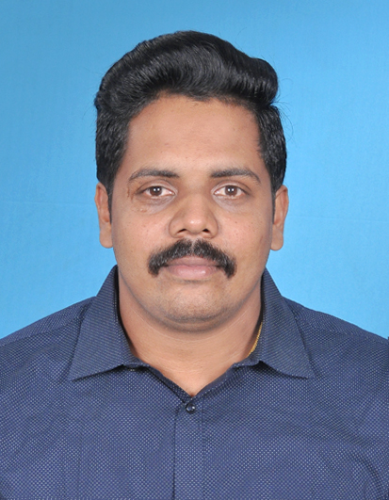

Career Objective:

To obtain a position of responsibilities that utilizes my skills, experience and where I can enrich my knowledge by contributing towards organization success.

Educational Qualification:

Degrees Awarded | College/School  (University/Board) | Year of Passing | Specialization | Percentage/  CGPA
MBA | Bangalore university, Karnataka | 2017 | Marketing & HR | 61
B.COM | Mahatma Gandhi university, Kerala | 2015 | Computer Application | 65
XII | State syllabus, Kerala | 2011 | Commerce | 75
X | State syllabus, Kerala | 2009 |  | 74

Certification:

Certification Title | Specialized | Year of Completion
Microsoft Office | Excel, Word, PowerPoint | 2017

Technical Quotient:

MS Word, MS PowerPoint, MS Paint, MS Excel.

Projects

Title: Study on Saving Habits of Kudumbashree Members (Major-Final Year B.COM)

Duration: 30 days

Description: How Kudumbashree members are finding out their income and how they are saving their income.

Title: A study on Trade Promotional Schemes of ScooBee Day Bags Pvt LTD. (Major- final year MBA)

Duration: 45 days

Description: Effectiveness of promotional strategies adopted by the company to increase their sales.

Experience

- Worked as Marketing Executive in Chennattu Industries, Pampady, Kottayam, and Kerala from 8th November 2017 to 31st January 2019.

Volunteer Activity

- Worked as Inter College Commerce fest student co-coordinator.
- Worked as National Service Scheme (NSS) Volunteer.
Achievements

Co-Curricular

- Participation in various management fests.
- Participation in Blood Donation Camp.
- Participation in NSS Seminars.

Personal Information

Father’s Name: Jose Thomas Occupation: Driver.
Mother’s Name: Sajini Jose Occupation: House wife.
Date of Birth: 11/08/1993
Hobbies / Interest: Travelling, Social Media, Playing Cricket, and Watching Movies.
Address for Correspondence (Permanent):
CHIRAKUZHIYIL (H)
MANGANAM P.O
KOTTAYAM
KERALA
Pin: 686018
Phone: +91-8907006097
Phone: +91-6238324154
E-mail:jibinjosec93@gmail.com
Language Proficiency:

Language | Read | Write | Speak
English | Yes | Yes | Yes
Malayalam | Yes | Yes | Yes
Tamil | No | No | Yes

Declaration:

I JIBIN JOSE hereby declare that the above mentioned information is correct and best of my knowledge and belief.

Date:
Signature

