Resume
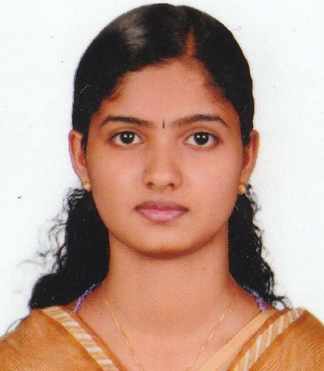

Jinu Jose
Email ID: jinujose353@gmail.com
Phone No: +918281189207

JOB OBJECTIVE
To secure a position as HR trainee at reputable organisation.

PERSONAL SKILLS
- Strong written and verbal communication skills
- Works well with others and has excellent interpersonal skills
- Initiative
- Decision making
EDUCATIONAL CREDENTIALS
- MHRM from Mahatma Gandhi University(pursuing)
- B.Sc. Chemistry from Mahatma Gandhi University, India with 9.04 CCPA in the year 2016.
- XII from St. Joseph HSS, Karimannoor, Kerala, India with 88% in the year 2012.
- X from St. Joseph HSS, Karimannoor, Kerala, India with 82% in the year 2010.
ACHEIVEMENTS
- Became a Volunteer in JRC at St. joseph’s Higher Secondary School, Karimannoor, Kerala, India
- Volunteer in Snehasangamam programme held at Nirmal College, Muvattupuzha, Kerala, India
- Internship from Chazhikattu Hospital, Thodupuzha, Kerala, India

PERSONAL INFORMATION
Permanent Address: Pathickal House
Pannoor P.O, Karimannoor
Thodupuzha, Idukki, 685581
Nationality: Indian
Date of Birth: 06-06-1995
Sex: Female
Marital Status: Single
Languages known: English, Malayalam
Computer Skills : Microsoft Word, Excel, Power point
PASSPORT DETAILS
Passport No: L8515051
Place of issue: Cochin
Date of issue: 03-04-2014
Date of Expiry: 02-04-2024
DECLARATION

I hereby declare that the information furnished above is true to the best of my knowledge.

Date: 06-02-2019
Place: Thodupuzha JINU JOSE

