CURRICULAM VITAE

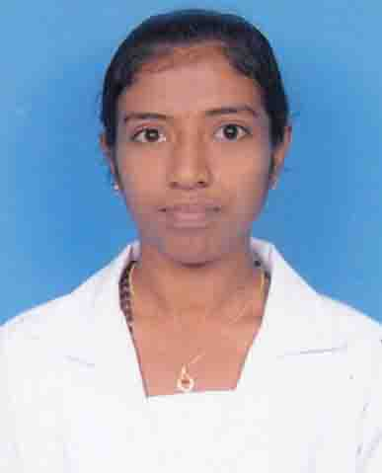

ELIZABETH JOHN
PALLIKANDATHIL
THATHAMPALLY PO
ALAPPUZHA
KERALA 688013
Phone 7034055318, 9497678318 (Mobile)
e-mail: elizabethlincy340@gmail.com

HEALTH PROFESSIONANAL- B Sc. NURRSE

Professional working with a state of the art medical institution of international repute as a staff nurse. Ability to effectively communicate and interact with patients, management and staff: promote a working environment which is conductive to increase productivity and efficiency; with good leadership qualities: dynamic and strongly committed to working with colleagues to achieve professional patient care with the human touch. Seeking an opportunity where my skills and experience will have a valuable impact.

PERSONAL DETAILS

Name | Elizabeth John
Date of Birth | 28th June 1994
Nationality | Indian
Marital Status | Single
Gender | Female
Religion | Christian
Caste | Roman Syrian Catholic
Diocese | Changanaserry
Parish | St. Michael’s Church, Thathampally
Languages Known | English, Malayalam, Hindi, Kannada
Kerala Nursing Council Application No. : BSC/REG/O/2018/5089

WORK EXPERIENCE

Working as staff nurse in Manipal Hospital since December 07 2016( 2YEAR)
Licenses
Registered Nurse-Karnataka Nursing Council
BLS Certification

Course | Institution and other details | Year
- Basic B. Sc Nursing | Rajive Gandhi University of Health science, Karnataka, Sri Venkateshwara College of Nursing, Bangalore | 2012-2016
- Plus two | SDV HSS Alappuzha, Kerala (Aggregate: 70.1%) | 2010-2012
- S.S.L.C | St.Michael’s HS Thathampally, Alappuzha Kerala  (Aggregate: 84%) | 2010

PROFESSIONAL TRAININGS
- Clinical and practical Psychiatric training at Spandana Hospitals, Bangalore from 01-05-2015 to 30-05- 2015
- Clinical and practical Obstetrics and Gynecology training at Victoria Hospital, Bangalore from 01-09-2016 to 10-09-2016
- Clinical and practical medical surgical training at RMV Hospital and KCG General Hospital at Bangalore.
ATTENDED WORKSHOP

- Nursing’s leadership role in caring of Patients with Dementia(Organized by INSCOL held at Sri Venketeshwara College of Nursing Bangalore on August 18, 2015)

REFERANCE

Dr. Jayasree Sreekumar | Director, Sri Venketeshwara College of Nursing Bangalore
Ms. Lakshmi | Principal, Sri Venketeshwara College of Nursing Bangalore  Ph. 9986322931
Ms. Ramzhan | Vice Principal, Sri Venketeshwara College of Nursing Bangalore  Ph. 8907701245

DECLERATION

I hereby solemnly declare and affirm that all the above particulars and information are true and correct.
Yours faithfully
Place: Alappuzha
Date: Elizabeth John

