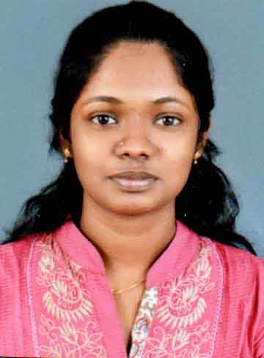
Ms. Saranya chandran

Curriculam vitae

CV Updated Date: 08/10/2018

Personal Details:
Name: MS. SARANYA CHANRAN
Date of Birth: 11/01/1990 | Age: 28 | Gender: FEMALE

Present Address: VADAYAZHOM,
KAITHAVANA ,
SANTHANAPURAM P O ,
ALAPPUZHA
KERALA
INDIA
PIN: 688009

Nationality: Indian | Marital Status: single
Passport No.: P7313279 | Passport Expiry Date: 17/02/2027

Contact Details:

Email ID: saranyachandran0787@gmail.com

Mobile No.:09496620787, 9947393691 | Skype-ID: saranya chandran

Summary:
Total Years of Experience | 4 YEARS AND 1 MONTHS
Highest Qualification | BSc NURSING
Current Designation | STAFF NURSE IN EMERGENCY DEPARTMENT

Education Details:
Sl. No. | Qualification | College / University | Duration of Study | Mode of Study | Start date of Study  (dd/mm/yyyy) | Graduation end date  (dd/mm/yyyy)
1. | BSc NURSING | BAGATH COLLEGE OF NURSING | 2008 TO 2012 | REGULAR | 30/08/2008 | 30/09/2012

License Details
No. of License: 1
Sr. No. | License Issued by | License No. | License Issued on | License Expiry date
1. | KERALA NURSES AND MIDWIFERY COUNCIL | 35817 | 22/05/2013 | 22-05-2018

Employment Details:
1. | Hospital Name: KERALA INSTITUTE OF MEDICAL SCIENCES, KOCHI
Location /Address: |  | PATHADIPALAM, CHANGANPUZHANAGAR POST,EDAPALLY,KOCHI-682033
Designation: : STAFF NURSE IN EMERGENCY DEPARTMENT |  |  | Start date:13/07/2015 | End date: 31/08/2018

Job Responsibilities:
WORKS AS A STAFF NURSE IN EMERGENCY DEPARTMENT AND LEADING TEAM AS A PRIMARY NURSE

. TAKING CARE OF PATIENTS IN VARIOUS EMERGENCY CONDITIONS
2. | Hospital Name: AMRITA MEDICAL COLLAGE OF MEDICAL SCIENCE , KOCHI
Location /Address: |  | AIMS P O, PONEKKARA , KOCHI-682041

Job Responsibilities:
- Management of patient’s care including admission and orientation of patient.
- Assessment of patient’s needs and planning care of the needs.
- Interpersonal relationship with higher authorities, co-workers and patient relatives.
- Management of supplies and equipments and keeping records and reports.
- Supervising juniors staffs in their works.

Certifications / Trainings undergone: ACLS AND BLS

REFERENCES

- Lt Col Ambika Kumari
Nursing Superintent
Kerala Institute of Medical Sciences
Pathadippalam,Edapally,Kochi.
Ph.9446063955.

- Brahmacharini sai Bala
Nursing Director
Amrita institute of Medical Sciences
AIMS P O
Ponekkara, Kochi-682041
Ph-914842851842

DECLARATION

I solemnly declare that all the above furnished information is free from error to the best of my knowledge and belief

Signature: Saranya Chandran
Place :- Pathadiplam
Date :-

