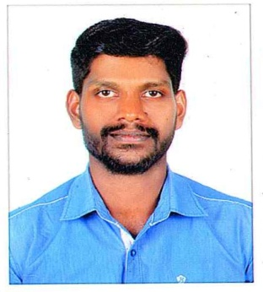
BIO DATA
SUDHEESH.P.S.
POLLAYIL HOUSE
THYCKAL P.O.
CHERTHALA
ALAPPUZHA -688530
Mob: 8086308928
E-Mail Id:- sudheeshsadanandan17@gmail.com

STRENGTH
A Strong Will-power, hardworking, efficient time-management, observation skill,disciplined,always friendly to others, eager to learn something new, Ability to work in teams as well as a leader when necessary.
EDUCATIONAL QUALIFICATION
COURSE | YEAR OF PASSED | INSTITUTE
B.Com Co.operation | 2015 March | MG University
Plus – Two | 2012March | St.F.A.H.S.S, Arthunkal
S S L C | 2010 March | St.F.A.H.S.S, Arthunkal

PERSONAL DETAILS
Name : SUDHEESH P.S.
Father’s Name : Sadanandan
Sex : Male
Date of Birth : 04/11/1994
Marital Status : Single.
Religion & Caste : Hindu, Dheevara
Language’s known : Malayalam , English & Hindi

DECLARATION
I do hereby declare that the information furnished above are true to my knowledge and I am confident of performing any task being assigned by the organization.
Place : Cherthala
Date : SUDHEESH.P.S.

