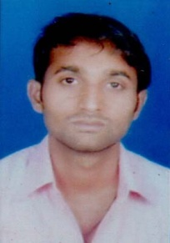
CURRICULAM VITAE
NAME : SUNIL KUMAR
MOBILE : 6394892771
E-mail ID : yashkumar5030@gmail.com
Career Objective

Looking forward for a career in an origination which can be provide excellent working atmosphere and mutual growth with an opportunity to share contribute upgrade and
enhance my knowledge.
Educational Qualification

Course | UG. Graduate | 2012 | Varanasi University
Other Qualification

Basic Knowledge of Computer Course.
Experience

I have 6 Year working of Housekeeping Team Leader in Mumbai Hotal Tip Tap Plaza
Personal Details

Name :- Sunil Kumar
Father’s Name :- Mr. Lal Bahadur
Mother’s :- Mrs. Phoolpatti Devi
Address :- Village- Cheksari, Post- Mujehara Chilh Thana
Distt. Mirzapur (U.P.) 231312
Date of Birth :- 17-Nov-1989
Gender :- Male
Nationality :- Indian
Marital Status :- Married
Declaration

I hereby declare that the mentioned information is true and genuine to the best of my knowledge and belief.

Date___/___/_____ Signature

