CURRICULAM VITAE
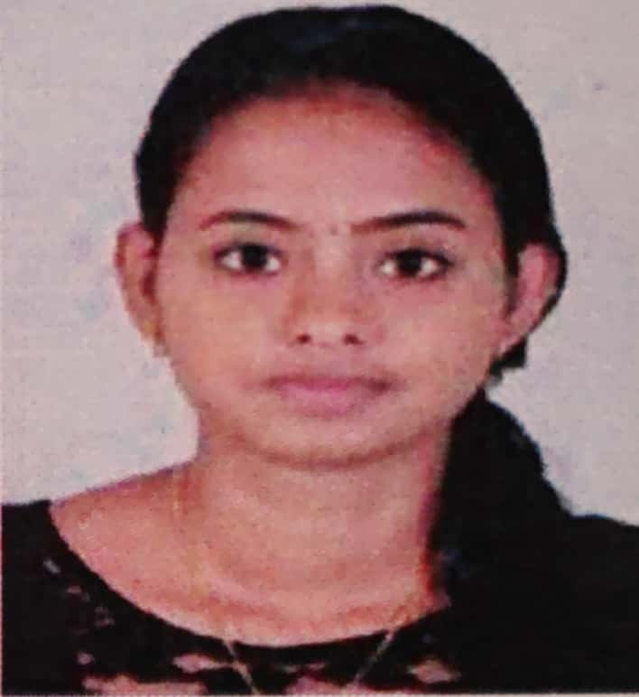
POST APPLIED FOR : STAFF NURSE
PERSONAL INFORMATION
Name : Miss NEETHU K.G
Father's Name : Mr Gopi K.R
Mothers' Name : Mrs Geetha M.S
Date of Birth : 16/09/1995
Age : 23 years
Sex : Female
Nationality : Indian
Languages : English, Malayalam,Hindi & Tamil
Permanent Address : Kadayath House
Vadacode P.O Kangarappady
Ernakulam,Kerala-682021
Contact Number : +918075798492
Email ID : neethukg13@gmail.com

REGISTRATION DETAILS
Kerala Nurses and Midwives Council No: KL03201802748
EDUCATIONAL QUALIFICATION
Qualification | School/College | Board/ University | Year of  Passing | % of marking
B. Sc Nursing | Govt college of Nursing Ernakulam | KUHS | 2017 | 69
XII ^{th} | Govt HSS Edappally | Higher Secondary Board, Kerala | 2013 | 86
Xth | Pius Girls High school Edappally | State Board of Public Examinations, Kerala | 2011 | 82

NURSING EMPLOYMENT HISTORY
No | Name and address  of employer | Designation | Department | Period
1 | Aster Medcity International Hospital Kutti Sahib Road Cheranelloore, Chittoor Kochi Kerala-682027 | Staff Nurse Grade II | Medical Surgical Ward | 01 Jan 2018  To  Present

CAREER OBJECTIVE
Ambitious and compassionate graduate nurse aspiring to practice, acquire and improve skills to promote health across the nursing care continuum. Desire to improve the health and wellbeing of the community I serve using a collaborative approach for quality health care.
PERSONAL ATTRIBUTES
- Sincerity and Punctuality.
- Ability to function independently in diverse assignments
- Dedication and Observation Skill
- Efficient in providing holistic quality health care to the assigned client using nursing process
- Awareness of the need of recording and reporting
- Coordination and control, of activity within the proffessional health care team
- Excellent communication skills
- Computer literature
EMPLOYMENT HISTORY
Dates of Employment : 01 Jan 2018 To Present
Name of Hospital : Aster Medcity International Hospital, Kutti Sahib Road, Cheranelloore,
City/State : Cheranellooore ,Ernakulam
Bed Capacity : 670
Job Title/Designation : Staff Nurse Grade II
Department/Ward Allocation: Medical Surgical Ward
Aster Medcity International Hospital Cheranelloore is a 670 bedded JCI&NADH accredited Quartarnary multi-specialty hospital. There is a 24-hour Emergency and theatre cover, a coronary care and ICU and all specialties. The Staff Nurse Grade II had 36 beds for all medical Surgical conditions.
EQUIPMENTS USED
Skin Traction, Anti Embolic Stoking, Pulse Oximeter, sphygmomanometer, Plaster Cast, Immobilisers, Pressure Vaccum, Suction Apparatus,Infusion,pump,Syringe pump, cardiac monitoring, Crash card,ventilator
WORK PERFORMA
Highlights
- Interpersonal skill
- Effective Time Management
- Skilled Communicator
- Multi Tasking Abilities

Duties and responsibilities
- Pre-operative and post-operative care of patients undergoing all medical surgical conditions.
- Applying skin tractions to the patients post-operatively.
- Provides surgical wound dressing under aseptic techniques.
- Assessment and management of pain.
- Discharge planning of the surgical patient.
- Mentoring student nurses when assigned to me
- Assisting junior nurses in orientation to the ward.
- Ward management in the absence of the head nurse.
- Documenting Nursing procedures in brief,accurate and complete manner
- Perform Nursing assessment of all patients,Plan,implement and evaluate nursing care rendered
- Administer oral and IV drugs as ordered by doctors
- Responsible for maintaining high standard of sterile and aseptic techniques in the department as per infection control protocol

REFERENCE
- Miss Lft. Col. Ajitha Nair
Chief Nursing Officer
Aster Medcity International Hospital Cheranelloore,
Phone :-9971798322
2. Mrs. Prof. Dr. Saleena Shah
Principal
Govt college of Nursing Ernakulam
3. Mrs.Sindhu Madhav
nursing officer
Aster Medcity International Hospital Cheranelloore,

DECLARATION
I hereby declare that the above-mentioned information is correct up to my knowledge and I bear the responsibility for the correctness of the above-mentioned particulars.

Place: Kalamassery NEETHU K.G
Date:

