RESUME
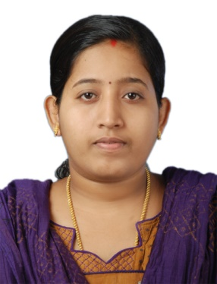
Anu A Nair
Kanjirakattu House,
Vengola P.O,
Arackapady,
Perumbavoor,
Kerala 683556
Email ID: sajanaanu@gmail.com
Mobile: +919061229606

CAREER OBJECTIVE
To obtain a position in a Health Care Facility, where i can utilize my skills , knowledge and experience to provide quality Health Care.

CAREER SUMMARY
- A dedicated, patient-focused registered nurse with proven experience in emergency and intensive care unit having experience of 2 year as a Nurse and 3 year experience as nursing tutor
- Proficient in providing the quality assistant to the doctors.
- Excellent in supervising the patient's condition.
- Expert in maintaining the health chart of the patient.

EDUCATIONAL CREDENTIALS
- Valid Kerala Nurse and Midwives Council Registration (BSc and MSc Nursing)
- Master of Nursing in Medical Surgical (2012-14), Rajiv Gandhi University, Bangalore, Scored 68.34%
- Bachelor of Nursing 2006-2010, Chaitanya College of Nursing, Bangalore, Rajiv Gandhi University. Scored 60.8%
- Plus Two, biology, HSE Kerala,2006, Tenth SSLC, Kerala, 2004

PERSONALITY TRAITS
- Strong work ethics and leadership skills.
- Excellent in communication skills in written and verbal.
- Ability to take care of patient excellently.

RESPONSIBILITIES HANDLED
- Manage the chart of patient.
- Follow the instructions and change the medicine according to them.
- Provide special assistance to the emergency room's patient.
- Manage multiple critically ill patients.
- Manage the documents of patient in regularly basis.
EMPLOYER
- Worked as CCU Staff Nurse at M.S Ramaiah Narayana Heart Centre, Bangalore (1/12/2017 to 03/01/2019)
- Worked as Nursing Tutor at Shree Laxmipati Mahavir Nursing School, Surat, Gujarat from 14/06/2014 to 30/08/2017
- Worked as BSC staff nurse at R.B SHAH MAHAVIR SUPER SPECIALITY HOSPITAL, Surat, Gujarat from 11.04.2011 to 30.04.2012.
PERSONAL DETAILS
- Sex: Female
- Marital Status: Married
- Date of Birth: 13.11.1988
- Husband’s Name: Sandeep K S
- Passport No: J7244924
- Passport expiry Date: 10/07/2021
- Nationality: Indian
- Hobbies: Shopping, Chatting, Watching Movies
- Languages known: English, Hindi, Malayalam, Tamil, Gujarati
DECALARATION
I hereby declare that whatever I have written above is true and correct to the best of my knowledge

Place: Perumbavoor ANU A NAIR
Date: 10.01.2019

