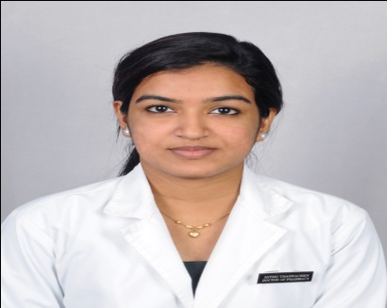

MITHU THANKACHAN

E – Mail:
mithuthankachan801@gmail.com

Contact Numbers:
+91- 8075046533
+91-7902566738

Present Address:
Vettomthadathil house,
Kanjirathanam PO,
Kottayam
Kerala- 686603.

PERSONAL DETAILS:

Father’s Name:

Mr. Thankachan Thomas

Mother’s Name:
Mrs. Mini Thankachan

DOB: 10 April 1994
Sex: Female
Nationality: Indian
Marital Status: Single
Languages Known:
English,
Malayalam,
Tamil

Objective

To pursue a career and grow successfully in a professional institution that would offer me a Challenging and Stimulating environment to work, along with scope for individual development. To extend all my efforts for the growth and development of the organization through creative and innovative ideas, keeping the organization’s goals as the priority.

Current Profile

CURRENT PROFILE

CURRENT PROFILE

Completed Clinical Internship Training in Doctor of Pharmacy including speciality postings. Internship activity includes,
- Ward Round Participation
- Providing Drug Information
- Patient Counseling
- ADR monitoring, detection, classification, reporting and documentation
- Pharmacoeconomic studies
- Treatment Chart Review
- Medication History Interview
- Drug Interactions
- Medication Errors
- Prescription Analysis
- Therapeutic Interventions
- Therapeutic Drug Monitoring

Internship Experience

- November 2017 - November 2018 in Various Wards in Sri Ramakrishna Hospital

(Ex: Surgery, Cardiology, Pulmonology and Orthopedics)

Educational Profile

COURSE | INSTITUTE | PERCENTAGE
SSLC (2010) | St. Mary’s High school Kuravilangadu | 86%
HSC GOVERNMENT OF KERALA BOARD (2012) | Emmanuel’s HSS Kothanalloor | 86%
DOCTOR OF PHARMACY  (2012- 2018) | Sri Ramakrishna Institute of Paramedical Sciences, Coimbatore, India  The Tamil Nadu Dr. M.G.R. Medical University-Chennai. India | 82%

Professional Experience

- PharmD Intern - 2017 to 2018
Sri Ramakrishna Hospital – Coimbatore

- Hospital Pharmacist – 2016 to 2017
Sri Ramakrishna Hospital, Pharmacy – Coimbatore

Academic Competencies
IIN

IN COLLEGE
- Expertise in query generation and management relating to the collection, processing, follow-up, analysis, and regulatory reporting of adverse events (AEs) and serious adverse events (SAEs).
- Computer savvy and effective utilization of drug and safety databases such as Micromedex, IDIS and etc.
IN HOSPITAL
1.Participated in the preparation of Drug Formulary.
2.Volunteered in the yearly Drug Stock Auditing.
3.Worked as a Pharmacy Indicator.
4.Participated in the Drug Information Center duty

Projects

Title: “Study on Medication Adherence among patients with Hypertension for Effective Therapeutic Outcomes ”

Conference Attended:

- IACP –Indian Congress Of Pharmacy Practice – 2016 & 2nd Convention of the Indian Association Of Colleges Of Pharmacy held at Coimbatore on April 2nd & 3rd , 2016.
- PARAMEDICAL DIABETES AND ENDOCRINE CONFERENCE – PARA DECON held on December 2nd 2017.

References

Dr. T. K. RAVI, M. Pharm., Ph.D. FAGE  Principal,  College of Pharmacy,  Sri Ramakrishna Institute of Paramedical Sciences,  Coimbatore - 641044.  Ph: +91 422 4500194, 4500164  Mobile: +91 98424 34412 | Dr. SRIRAM. S, M. PHARM., Ph.D.  Head of the Department of Pharmacy Practice,  College of Pharmacy,  Sri Ramakrishna Institute of Paramedical Sciences,  Coimbatore - 641044.  Ph: +91 422 4500297  Mobile: +91 94435 78064

Declaration:
I hereby declare that all the above-mentioned information is correct and true to the
best of my know

