RESUME
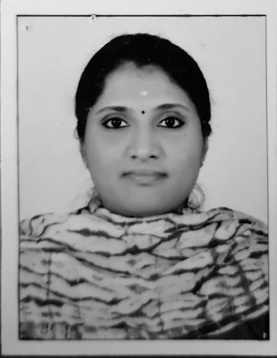
UMA M M
Marunninakulath (H)
Madaplathuruth
Moothakunnam P.O.
North Paravur
Ernakulam Dist
Kerala
Mob: 9847252345
Mail Id : umamohandas1@gmail.com

OBJECTIVE
Seeking entry level assignments in Human Resource Management with an organization of high repute.

ACADEMIC PROFILE
- MBA(HR / INFORMATION SYSTEM) – SNGIST College
(MG UNIVERSITY 2014-216)
- BCA – HMCT (MADURAI KAMARAJ UNIVERSITY - 2012)
- Higher Secondary – AMMHSS (2008)
- SSLC – ST. ALOYSIUS HIGH SCHOOL (2006)

OTHER ACADEMIC RELATED ACTIVITIES
- Diploma in Professional Accounting (2012-2013)
- Supply Chain Logistics Management

COMPUTING SKILLS
- MS Office
- Visual Basic
- Tally ERP
- Peachtree Accounting

PERSONAL DETAILS
Name : Uma M M
Date of Birth : 01 June 1990
Father’s Name : (L) Mr. M N Mohandas
Mother’s Name : Thankamony G
Husband’s Name : Devadathum I V
Gender : Female
Marital Status : Married

REFERENCES
Mr. Vignesh Karthik S A
Assistant Professor, Sree Narayana Guru Institute of Science and Technology, N.Paravur.
Mobile Number: +919995275908
DECLARATION
I hereby declare that the above mentioned information is true up to my knowledge and I bear the responsibility for the correctness of the mentioned particulars.

Place : Moothakunnam
Date : UMA M M

