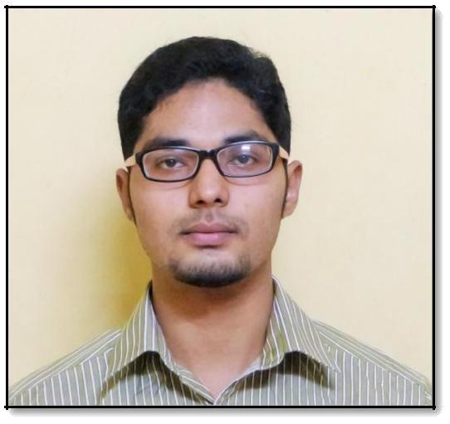
DAWOOD IBRAHIM. S

Punam Mandara,
No#979, S1 Flat,7th main road
Gandhi nagar,
Kengeri satellite town

Bangalore - 560060
Communication Details Mobile: 91 9591589651
Residence: - 91-9008012380
E-mail: dawoodibrahim665@gmail.com

CAREER OBJECTIVE:

To be a part of challenging team which strives for the growth of the organization as well as personnel and which explores my potential and provides me with the opportunity to enhance my talent with an intention to be an asset to the company.

SCHOLASTIC RECORD:

Certified Professional in Healthcare Quality - Anexas, South East Asia

Certified Lean Six Sigma Green Belt - Anexas, South East Asia

Graduation – BHA - (Bachelor’s in Hospital Administration) – Padmashree College Of Hospital Administration.

Pre University – (CEBA) Sheshadripuram Pre University.

Schooling – Vidyaniketan Public School ‘CBSE’.

SKILLS AND COMPETENCIES:

- Strong verbal and written communication skills.

- Astounding Reasoning and Logical skills

- Well built interpersonal and influencing skills.

- Efficient and organized with ability to prioritize and multitask.

PERSONAL DETAILS:

- Date of Birth – 27-July-1995

- Passport number – N5294569

- Sex – Male

- Nationality - Indian

- Religion - Muslim

- Language Proficiency – English, Tamil, Urdu, Hindi, Kannada.

WORK EXPERIENCE:

Al-Ameen Hospital, Bangalore from Jan-2018 to Present

Administrator and Quality Coordinator:

- Heading the unit and handling a team of 15+ Doctors, 3 Trainers and 40+ administrative staffs.

- Handling Quality, HR Operations, Payroll Administration and Recruitment.

- Quality Control Training and NABH internal audit support.

- SPOC for Marketing, Purchase and Equipment Maintenance.
- Achieved Pre-accreditation NABH approval for my unit.

- Conducting mock drills, reporting of incidents, patient counseling and improving the patient flow in the hospital.

- Conducting free health to care campaigns.

APOLLO Hospital, Bannerghatta from Dec-2016 to Feb-2017
HR Intern:

  - Worked as an Intern for a period of 3 months in HR Department as a part of BHA curriculum (Dec 2016 – Feb 17).

- Making Corporate Reports(L&D) -

(Jaynagar, Sheshadripuam, BG unit)

- Auditing Employee files ( Nursing, Doctors, Support Staffs).

- Training compliance.

- Making training certificates for employees.

- Making calls for nomination of employees in training Programmes

- Assist Trainers and L &D Team in conducting Training Programmes.

- Making Training Calendar.

- Assist in making Departmental Budget.

- Making Individual Training card for employees.

- Data Entry of Training attendance.

- Feedback Analysis of Employee

FORTIS Hospital Nagarbhavi, from Apr-2015 to Aug-2015
Quality and Operations Intern:

- Worked as an intern for a period of 5 months as a part of BHA curriculum.

- Assist in Quality control programs.

- Designed New MRD formats.

- Deficiency check listing in MRD

- Collection of patient feedback forms.
- Consent audits and Monthly Audit Data.

- Conducted Health camp for National Law College.

MANAGEMENT SKILLS AND COMPETENCIES:

- Ability to handle all Hospital scopes. (Human Resource, Operations, Quality)

- Initiative in organization and management of events and problem solving.

- Project management and Presentation skills.

- Ability to work under extreme stressful conditions and round the clock.

ACHEIVEMENTS:

- Trained for ‘Connect to Collaborate’ by DALE CARNEGIE TRAINING.
- ttended 3rd International healthcare technology conference (CAHOTECH-2018).

- Participated in the One day workshop on Health Care Communication.

- Participated in First National Health Summit 2017 – Bengaluru

- Participated in Polio immunization program.

- Marketing for Tejasco Medinfo Tab program.

- Attended most of the healthcare conferences in India.

- Represented U -18 football in district level.

- Tally 9.0 certificate and soft skills.

- Won most of the inter collegiate sports events.

INTERESTS:

- Travelling, Trekking and Adventure sports

- Cooking, Swimming and reading novels

- Soccer, Athletics, Badminton and Gymnasium

I do hereby declare that all the information provided above is true to the best of my knowledge and belief.

[Dawood Ibrahim.S] Date:

