CURRICULUM VITAE

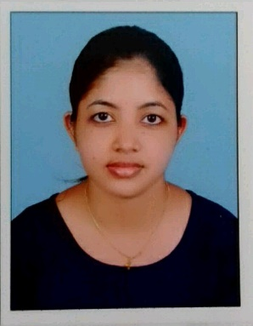
FEMY VARGHESE
Kalambattukudy House
Aimury, Koovappady P.O
Ernakulam – 683544
Kerala, India

E-mail : femyvarghese94@gmail.com
Contact No. : +91 7510280644

CARRER OBJECTIVE
To join a reputed and growth oriented health organization where I could utilize my medical knowledge and good patient serving skills to improve client satisfaction for the benefit of organization and self.

EDUCATIONAL QUALIFICATION:
NAME OF EXAMINATION | YEAR OF PASSING | COLLEGE/  SCHOOL | UNIVERSITY/  BOARD | PERCENTAGE
Pharm. D | 2018 | St. James College of Pharmaceutical Sciences, Chalakudy, Kerala | Kerala University of Health Sciences (KUHS) | 74.93%
HSC | 2012 | St.Augustine’s  GHSS  Kothamangalam | Kerala Higher  Secondary  (HSE) | 89%
SSLC | 2010 | St. Joseph’s GHS  Chengal, Kalady | SSLC | 88%

TRAINING:
One year internship programme from St. James hospital Chalakudy – Thrissur. (2017-2018)

ACADEMIC PROJECTS:
“Drug use pattern in pregnancy: A prospective observational study at a tertiary care
Hospital”.
PERSONAL SKILLS:
- Written and verbal communication skills
- Sincere to work
- Quick learning and strict update of knowledge and skills
- Flexibility and ability to adapt any situation
- Good team worker
SEMINARS AND WORKSHOPS:
- Participated in “Indian Congress of Pharmacy Practice 2016 & Convention of the Indian Association of College of Pharmacy”
- Participated in “1st Pharmaceutical Sciences Congress-2017”
- Participated in a two-day seminar on “Prospectives and Reflections on Patients’ Rights”
- Participated in “Pharmacy Practice Module – Advanced Learning Series 5-2013”
- Conducted Cancer Survey Programme organized by Govt. of Kerala.
- Participated in Health Awareness Programme at Chalakudy on the event of World AIDS Day
- Volunteered various medical camps

TECHNOLOGY SUMMARY:
Applications : Microsoft Office (Word, Excel, Powerpoint),

Platforms : Windows (98/2000/XP/7/8/10)

PERSONAL DETAILS:
Date of Birth : 19th September 1994
Gender : Female
Nationality : Indian
Religion : Christian
Marital Status : Single
Languages Known : Malayalam & English.
Hobbies : Reading Articles, Listening Music, Gardening
REFERENCES:

Name | Dr.K.Krishnakumar | Dr.L. Panayappan
Designation | Principal,  St.James college of pharmaceutical sciences, Chalakkudy | Head of Department,  Department of pharmacy practice,  St.James college of pharmaceutical sciences, Chalakkudy
Contact number | 9747123478 | 9585333000

DECLARATION:
I solemnly affirm that the above furnished particulars are true to the best of my knowledge and belief

Place: Aimury
Date : FEMY VARGHESE

