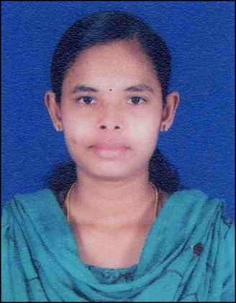
Curriculum Vitae

Tinu Joshy,
D/o Mr. Joshy A L,
Anjikkal (H),Olanad,
Varapuzha P.O,Ernakulam
PIN:683517
Ph – 9061574177,9526586133

OBJECTIVE

To work in a premier organization or firm by giving my best performances in every aspects of work and attain self development by continuous learning.

EDUCATIONAL QUALIFICATION

DEGREE | INSTITUTION | BOARD UNIVERSITY | YEARS | %
B.Sc Nursing | Sidhi Sadan lourde College of Nursing, Ernakulam | KUHS University | 2015 | 62%
HSC | GHSS Kongorpilly | State Board | 2010 | 74%
SSLC | St.George HS, Puthenpally | State Board | 2008 | 80%

HIGHLIGHTS OF QUALIFICATION

- Personable with a positive attitude, interface well with patients, families and nursing staff
- Hard working and energetic, flexible, adopt easily to change of environment & work schedule
- Maintain critical thinking skills essential for providing competent and dignified patient care
- Team leader with ablility to create a positive working environment that uplifts patient spirits.
PERSONAL SKILLS
- An active member of Student Nurse Association (S.N.A)
- Was active in cultural programmes

FUNCTIONAL STYLES
- Humble, caring, flexible, versatile, gentle, empathetic and sincere.
JOB RESPONSIBILITY AS A STAFF NURSE
- Assisting the client to meet activities of daily living
- Meeting the hygienic needs of the client
- Monitoring vital parameters
- Doing wound dressing
- Maintain aspesis
- Admission & discharge of patient
- Handling emergency chart along with defibrillators
- Insertion and care of NGT’s, Foley’s catheter
- Administration of medications
- Attend doctors rounds
- Maintain records & reports
DUTIES AND RESPONSIBILITIES

- Responsible for health care management of patients in ward
- Experience in handling equipment like syringe pump, infusion pump, cardiac monitor, pulse oxymeter etc
- Admitting, transferring and discharging the patients
- Wound dressing, suture removal, surgical skin preparation and IV Cannulation
- Blood transfusion, ryles tube insertion, bladder catheterization.
- Administration of anesthetic medications through epidural catheter
- Insertion of oral and Naso- Pharyngeal air ways
- ECG recording and collection of specimens and monitoring vital signs
- Routine nursing care like maintain patients hygiene, prevention of pressure sores, checking blood sugar, providing balanced diet with the help of dietician, maintaining intake output chart
- Assisting medical officers while on rounds and making notes of instruction
- Pain management
- Collecting blood for a arterial blood gas studies
- Pre and post care of patients undergoing all surgical procedures

PERSONAL INFORMATION
Date of birth : 07-01-1994
Gender : Female
Father’s Name : Joshy A L
Mother’s Name : Jancy Joshy
Mother Tongue : Malayalam
Nationality : Indian
Marital Status : Single
Religion : Christian
Hobbies : Reading, listening to music, cooking
Languages Known : English, Malayalam, Hindi
Permanent Address : Anjikkal (H),
Olanad,,Varapuzha P.O,
PIN:683517, Ernakulam

EXPERIENCE
- Presently working in Emergency Dept at Lourde Hospital,Ernakulam from 2016
REFERENCE
- Sr. Lilly ,
Principal,
Sidhi sadan,
LourdesCollege of Nursing,
Ernakulam
Ph: 0484-412345
- Fr. Shiju Thopill
Lourdes hospital,
Pachalam, Ernakulum

DECLARATION

I do hereby declare that the particular of information and facts stated here in above are true and correct and complete to the best of my knowledge &belief.

Place: Varapuzha
Date : 10.12.2017 TINU JOSHY

