CURRICULAM VITAE
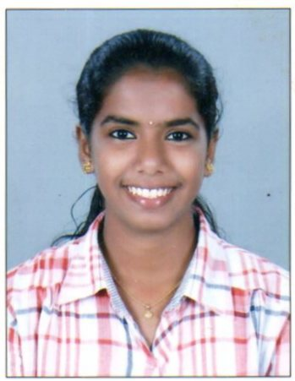
METILDA CLEETUS Kanappilly House
26/585, Beach road,
K.S.H.B Colony,
Mattancherry p.o,
Ernakulum
Kerala. Pin 682002
Ph:7510859670,9037511470
Email: steffy12061996@gmail.com
Career Objectives
To seek a position in a reputed organization and invest all my experience and all my experience and qualification to enhance the organization growth

.

Personal details
Date of Birth : 12/06/1996
Sex : Female
Nationality : Indian
Father's Name : Cleetus K.J
Religion & Caste : Christian, Latin Catholic
Marital status : Single
Language Known : Malayalam, English, Tamil, Hindi, Sanskrit

EDUCATIONAL QUALIFICATION

SL. | Qualification | Institution | University | Year of pass | Marks Obtained
1 | SSLC | O. L.C.G.H.S, Palluruthy | State board | 2012 | 94%
2 | HSE | E.M.G.H.S.S Fort Kochi | State board | 2014 | 86.6%
3 | BSc Nursing | Mother college of nursing , Thrissur | Kerala University Of Health Science | 2018 | 69.28%

Skills and Abilities
- Self confident
- Time management
- Logical & Quick thinking
Special talent
- Hard working and sincere with ability to work as part of team
- Efficient organizer
- Strong presentation and communication ability
- Able and willing to accept high level of responsibility , willing to learn
- Sincere and loyal , self motivated, reliable and trust worthy, leadership potential
Computer Literacy
- Basic knowledge of computer
- Internet Knowledge
References
- Prof. Mrs. Ushanandini Rajesh, Principal Mother College of Nursing Thrissur, Kerala, Ph No: 7025155999
- Mrs. Roycemol A R, Associate professor Mother College Of Nursing, Thrissur, Kerala, Ph No : 9447959931

DECLARATION
I hereby declare that the above mentioned statements are true and correct to the best of my knowledge and belief

Place : Kochi
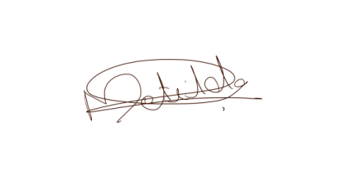
Date : METILDA CLEETUS

