RESUME
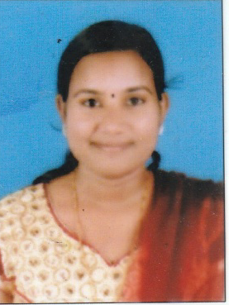
ARATHY PRASAD
Olavathara House
Punnapra North P.O
Alappuzha, Kerala 688014
PH : 9383452827, 8593820927
Email : arathyshibu1993@gmail.com

Objectives
- To be a part of the successful working of the organization.
- To contribute all my talents and abilities for the moulding of students.
- To become a good teacher, a friend, philosopher and a guide.

Educational Qualification

Course | University | Institution | Year
SSLCs SSLC | Board Board of Kerala | St.Jose st’joseph Hs,Punnapra | 2010 2010
Plus T PLUS TWO | Board Board of Kerala | Arav Aravukad HSS, Punnapra | 2012 2012
Bsc BSC | Rajeev RajeevGandhi | Ashrit Ashrith College of Nursing,  Kota, Uduppi | 20162 2016

Personal Profile

Name : Arathy Prasad
Sex : Female
Marital Status : Single
Religion : Hindu
Caste : Ezhava
Date of Birth : 26/08/1993
Age : 24Years
Father’s Name : K.Siva Prasad
Mother”s Name : Beena Prasad
Contact No : 9383452827, 8593820927
Experience : 1 year in TDMCH vandanam

Personal Activites
- Creative Writing, Reading , Listening Music, Social Service.

Declaration
I hereby declare that all the above facts are true and correct to the best of my knowledge and belief.

Date : ARATHY PRASAD
Place :

