CURRICULUM VITAE
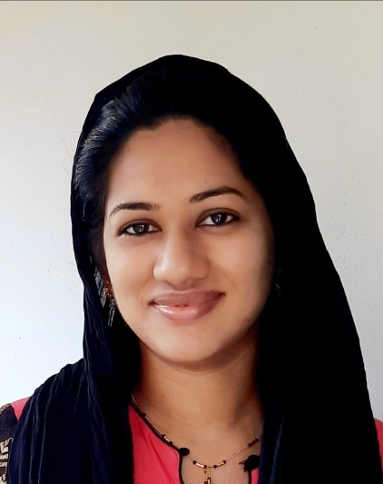

AMEENA JALEEL
drameenajaleel@gmail.com
QUALIFICATIONS : MBBS, MD DVL
Name : DR. AMEENA JALEEL
Sex : FEMALE
Age : 31 YEARS
Date of birth : 24-07-1987
Father’s name : MR. K.K ABDUL JALEEL
Mother’s name : MRS. SABAH JALEEL
Spouse’s name : DR. JEBIN IBRAHIM, MD RADIODIAGNOSIS
Permanent Address :‘AFIF MANZIL’, H. NO – 44/2351-B
UNITY LANE, KALOOR P.O, KOCHI-17,
ERNAKULAM, KERALA, INDIA.
Contact number : Residence – 0484-2531249
: Mobile – 9495958496, 9074749569
Email id : drameenajaleel@gmail.com
EDUCATIONAL QUALIFICATIONS
X & XII : Bhavan’s Varuna Vidyalaya, Thrikkakara
Board : CBSE (Central board of secondary education)
AISSE & AISSCE -2003 & 2005 respectively
Degree : BACHELOR OF MEDICINE & SURGERY (MBBS)
Institution : GOVT. MEDICAL COLLEGE, THIRUVANANTHAPURAM, KERALA.
University : UNIVERSITY OF KERALA, THIRUVANANTHAPURAM.
Period of Course : JULY 2006 TO NOVEMBER 2012
Year of Passing : NOVEMBER 2011
Percentage marks : 72 %
Registration number : 46412
Internship : AT GOVT. MEDICAL COLLEGE, THIRUVANANTHAPURAM
NOVEMBER 2011 TO NOVEMBER 2012

Post graduate Degree: MASTERS DEGREE IN DERMATOLOGY VENEREOLOGY & LEPROSY (MD DVL)
Institution : GOVERNMENT MEDICAL COLLEGE, KOTTAYAM
University : KERALA UNIVERSITY OF HEALTH SCIENCES (KUHS).
Period of Course : JULY 2014 TO NOV 2017
Thesis : “A CLINICOPATHOLOGICAL AND ELECTROPHYSIOLOGICAL STUDY OF NERVE INVOLVEMENT IN HANSEN’S DISEASE”
Year of Passing : 2017
Junior Residency` :Dept. of Dermatology, Kottayam Medical College, from July 2014 To October 2017
WORK EXPERIENCE- Working as Senior Resident at Dept. of Dermatology, Kottayam Medical College since January 2018
- Proficient in performing various cosmetological and surgical procedures like
- Radiofrequency, Electrosurgery, Cryosurgery, Chemical cautery, Intralesional Steroid injections, Mole excision surgeries, Sebaceous cyst excision, Nail avulsion, Skin biopsy, Nail biopsy, Nerve biopsy, PRP and PRF, Autologous Serum Transfer, DPCP
- Acne scar surgeries like subcision, Dermabrasion, microneedling, PRP, punch excision
- Vitiligo surgeries like mini-punch grafting, suction blister grafting, Non cultured melanocyte transfer surgery
- Botox injection for palmar and axillary hyperhidrosis
- Comprehensive training in various LASER treatments like Diode laser, Q switched Nd-YAG laser, CO2 lasers(Ablative and non-ablative), IPL, OSCAR
.
AWARDS:
- Dr. B.K.H Nair Memorial Award 2018 by IADVL-KERALA – for best young researcher for research work entitled ‘ A clinicopathological and electrophysiological study of nerve involvement in Hansen’s Disease’.
- Award paper at Cuticon kerala, 2015, Kannur
- First prize at dermatopathology quiz at Dermatopathology CME, Thiruvananthapuram

PAPERS AND POSTERS PRESENTED
PAPERS: PG Analogues for Digital Cure (CUTICON KERALA, 2015, KANNUR)
Fairness Faddism : Unveiling the mask (MIDCUTICON KERALA, 2016)
Nevirapine Rash and CD4 count in HIV patients ( ASTICON 2015, Coimbatore)
POSTERS: PAN- An unusual presentation (SARCD 2015, Mysuru)
PG Analogues for Digital Cure (DE RMACON 2016, Coimbatore)

INTERNATIONAL PUBLICATIONS
Jaleel A, Celine MI, Sobhanakumari K, Sadanandan SM, Shanimole PE, Sobhana Surendran S. Mycetoma-like chromoblastomycosis: a diagnostic dilemma. Int J Dermatol. 2017;56:563–6.
CONFERENCES ATTENDED

- CUTICON KERALA 2015; KANNUR
- SARCD 2015, MYSURU
- ASTICON 2015, COIMBATORE
- MID-CUTICON KERALA 2016, THRISSUR
- CUTICON KERALA 2016, KOCHI
- DERMACON 2016, COIMBATORE
- DERMACON 2017, KOLKATTA
- DERMACON 2018, KOCHI
CME’S ATTENDED
- Light in Dermatology: Boon and Bane (Dept. of dermatology, kottayam medical college; June 2016)
- Dermatopathology CME kerala 2016, Thiruvananthapuram
- Dermamaze I 2017, Kottayam Medical College
- Dermamaze II 2018, Kottayam Medical College
- ACSI live workshop on procedural dermatology, July 2018, Thiruvananthapuram

PERSONAL STRENGTHS:
Honesty, commitment, quick decision making, strive for perfection, good interpersonal relations and always open for learning and sharing
WORK EXPERIENCE
- Assistant surgeon in Taluk Hospital, North Paravur, March 2014 to May 2014.
- Senior Resident in Dept of Dermatology from Jan 2018 to present.

