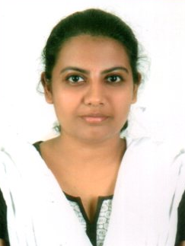
Dr. STEFFI A
6/22, Bethel, Vandanganavilai,
Ayinkamom, Kaliakkavilai Post,
Kanyakumari Dist-629153
E.mail: steffi.4201@gmail.com
Phone No: 7305297471

PROFESSIONAL SUMMARY:
Disciplined and hard working doctor with extensive experience in top notch hospitals. Looking to work in an environment which is challenging and educative.
HIGHLIGHTS:
- Good bedside manner
- Excellent Listener
- Honest and forthcoming
- Empathetic and courteous
EXPERIENCE
May 2018 – Oct 2018 - Junior Resident
Sree Gokulam Medical College Trivandrum.
- Attended daily rounds with the senior doctors and followed up on the advided administration of drugs and the necessary investigations.
- Pre and post operative care
- Counseled patients on preventive care
- Worked in Cardiology
17 August 2015 – Nov 2017- Junior Resident
DM Wayanad Institute of Medical Sciences, Wayanad.

- Appropriate investigations and diagnosis
- Developed open rapport with the patients encouraging questions about their medical conditions.
- Counseled patients on preventive care
- Worked in neurosurgery, dermatology, pediatrics and forensic medicine on rotational basis.
May 2014-Arpil 2015 - Medical Officer
Dr. Kamakshi Memorial Hospital, Chennai
- Prompt investigations and treatment based on the presenting sumptoms and signs in the casualty.
- Detailed history taking, examination and maintaining an up to date record of the patients treatment and response.
- Pre and post operative care
- Maintaining a friendly relationship with other medical personnel
EDUCATION
2008 – 2014 BACHELOR OF MEDICINE, BACHELOR OF SURGERY
Sree Balaji Medical College and Hospital, Chennai
LANGUAGES
- English
- Malayalam
- Tamil
- Hindi
REFERENCES:
- Dr. Dr. Biji Soman (Cardiology)
- Dr. Sudeshini Mirza ( Forensic Medicine )

