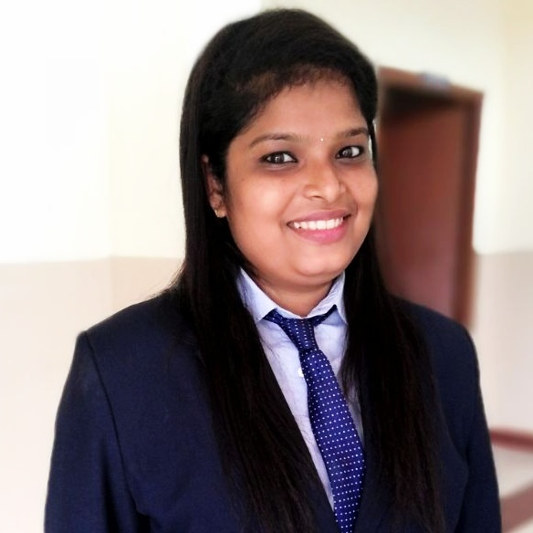

DIMPLE JOSEPH
Mob: +91 9495588534
E-mail: dimplejoseph85536@gmail.com

CAREER OBJECTIVE
To be a part of an organization where get a chance to use my knowledge and skills to contribute in the progress of the organization as well as myself.

EDUCATIONAL QUALIFICATIONS

Course | Specialization | University/board | Percentage | Year of completion
MBA | Hospital administration  & Logistics | Mangalore university | 58% | 2018

PROJECT
- Title – A study on work safety for employs in radiology department at Bharath cardiovascular hospital
Kottayam

- Role – To analyze of hand hygiene practices among health care workers in Radiology department
INTERNSHIP
- PG LEVEL
Organization – E K Nayanar Memorial Co-operative Hospital Chengala ,kasargod
Period – 31 days

Duration – 01/07/2017 to 31/07/2017
Role – Understanding the functions of different administrative departments in E K Nayanar Hospital.

CO-CURRICULAR ACTIVITIES

- Conducted cancer awareness session on 7/03/2018 at A.J institute of management under hospital administration club
- Conducted blood donation camp on 8/05/2018 at A.J institute of management under hospital administration club

PERSONAL DETAILES
Date of birth - 09/03/1993
Mother’s name - Marykutty Joseph
Father name - Joseph M D
Languages known - Malayalam (Native), English,
Hobbies - singing, listening to music, Watching TV,
Permanent address - Mannoor(h),Kadanadu (p.o),Kottayam (dist),kerala
India

REFERENCE
Dr. T Jayaprakash Rao
Director – A.J Institute of Management, Mangalore
Mob: 9448812099

DECLARATION
I do hereby declare that above mentioned facts are true to the very best of my knowledge and belief.

Kottayam , Kerala
24/07/18 DIMPLE JOSEPH

