**CURRICULAM VITAE**

**CURRICULAM VITAE**

**OBJECTIVE**

**AMITHA VIJAYAN**

**E-Mail**  [amithavijayan5@gmail.com](mailto:amithavijayan5@gmail.com)

**Mobile**  **+91-95 44 92 90 89**

**PERMANENT ADDRESS**

***Kizhakkeveettil House***

***Kinginimattam P O***

***Kolenchery Via***

***Ernakulam District***

***Kerala***

***Pin:682311***

**PERSONAL PROFILE**

**Father’s Name : Mr. K R Vijayan**

**Age and D.O.B : 24, 05.11.1994**

**Sex : Female**

**Religion, Caste : Hindhu, Viswakarma**

**Marital Status : Single**

**Nationality : Indian**

**KNMC Reg.NO : KL04201704167**

***To pursue a challenging career and be a part of progressive organization that gives a scope to enhance my knowledge and utilizing my skills towards the growth of the organization***

* **P**assed **–** B.Sc Nursing from NTR University of Health Sciences, Vijayawada at SVS College of Nursing, Mahabubnagar in the year of 2016 with 71% of Marks
* **P**assed – Plus Two at GHSS Poothrikka (Board of Higher Secondary Examination, Kerala) in the year of March 2012 with 72% of Marks
* **P**assed – SSLC from GHSS Poothrikka (Board of Public Examination, Kerala) in the year of 2010 with 70% of marks
* 1 Year experience as a staff nurse in Psychiatry ward at MOSC Medical College Hospital, Kolenchery from 7.11.2017 to 7.11.2018.
* 6 Months experience in Cardiac ICU at Asian Heart Institute and Research Centre, Mumbai
* Malayalam
* English
* Hindi
* Telugu
* 2015 - Preventing health care associated infection Nurses “Concern”

***I hereby declare that the above mentioned details are correct to the best of my knowledge and belief.***

**Place: Puthencruz ASHA K RAVINDRAN**

**Date:**

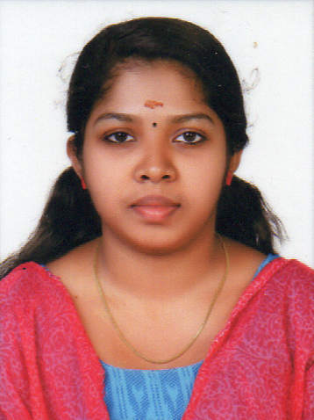

**ACADEMIC PROFILE**

**EXPERIENCE DETAILS**

**LANGUAGES KNOWN**

**COURSE ATTENDED**

* A Study to assess the knowledge regarding effectiveness of dep breathing and coughing excercises amon postoperative clients in Male surgical ward at SVS hospital, Mahabubnagar, Telangana.

|  |  |  |
| --- | --- | --- |
|  |  |  |
|  |  |  |
| * Remain calm and professional throughout critical incidents * communication skills * Resourceful problem solving capability. * Ability to work in different shifts * Emotional stability * Empathy * Physical endurance * Punctuality * Adaptability in different teams |  |  |
|  |  |  |

***I hereby declare that the above mentioned details are correct to the best of my knowledge and belief.***

**Place: Kolenchery AMITHA VIJAYAN**

**Date:**

**RESEARCH ( During Course)**

**AMITHA VIJAYAN**

**PERSONALITY TRAITS**

**DECLARATION**