CURRICULUM VITA
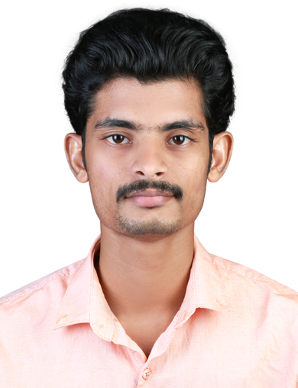yoere

Jibin Jose
Thrissur
Mobile : 8893632220
Email ID : jibinjose792@gmail.com

CAREER OBJECTIVE

Looking for a challenging position in a reputed hospital where my profound medical professional and practical experience will be fully utilized.
PERSONAL PROFILE
Date of Birth : 19-07-1992
Gender : Male
Present Address : Cheruvathoor House, St. Antony’s Street, Kuriachira P.O,
Thrissur, Kerala, PIN:680006
Permanent Address : Cheruvathoor House, St. Antony’s Street, Kuriachira P.O,
Thrissur, Kerala, PIN:680006
Marital Status : Single
E-Mail ID : jibinjose792@gmail.com
Contact Number : 8893632220
Father's Name : C.O. Jose
Mother’s Name : Pushpam Jose
Languages Known : English, Hindi and Malayalam (Read/Write/Speak)
Mother Tongue : Malayalam
Hobbies : Music, Reading books.

EDUCATIONAL QUALIFICATION

Course/Exam Passed | College/University | Year of passing
SSLC | Mar Thimotheus High School,  Chelakkottukara, Thrissur, Kerala | 2008
PLUS TWO | Chaldean Syrian Higher Secondary School, Thrissur, Kerala | 2010
GNM Nursing | School of Nursing, Trichur District Co-operative Hospital, , Kerala | 2014
POST BASIC BSC Nursing | Medical Trust College of Nursing,  Ernakulam, Kerala | 2016

REGISTRATION STATUS

Nursing Registration | Registration No | Registration Date
Kerala Nursing Council GNM | KL01201400471 | 16-06-2014 valid upto 15-06-2019
KUHS  Post Basic Bsc | KL01201400471 | 01-04-2017

TECHNICAL EXPERIENCE

- Give compassionate care to critical care patient from injuries and debilitating condition.
- Proficient in almost all apparatus and equipments
- Perform first aid in CPR Management
- Giving injections (IV. IM, subcutaneous, skin testing)
- IV cannulation and blood samples extraction
- Local surgical wound care, perform medical procedures and treatment.
- Insert foley’s catheter and Ryles Tube
- Assist doctors for HD Cath,CVP and Arterial line insetion
- Handling Ventilator Patients with CRRT and Dialysis
- Assist for Tracheostomy,Endo-tracheal intubation,Bone marrow aspiration,Lumbar Punture,pleural tapping and Bronchoscopy
- Handling all emergency situations
- Responsible for the laboratory equipments and handling patient
- Proficient in basic use of computer.

WORK EXPERIENCE

May 1, 2017 (1.6yrs) – Current in Medical ICU (Max Superspeciality Hospital, Patparganj, Delhi)
ACLS AND BLS CERTIFICATION
- Give compassionate care to critical patents suffering from injuries or debilitating conditions
- Critically assess patient conditions and adeptly handled all aspects of treatment from medication to found care to monitoring 2-3 patents per shift
- Manage life support equipment and IV administration of fluids and medication
- Monitor telemetry and respond to codes
- Observe beavers and Symptoms and report changes to on – call Physicians
- Educate families about patent condition and provide support as needed

PERSONAL ABILITIES

- Willing to strive and work hard
- Ability to grasp new methods and technologies in short time
- Winning attitude
- Simple and Honest
- Remain calm and professional throughout critical incidents.

REFERENCES

- Mr. Rijo Jose
Principal
School of Nursing, Trichur Dist. Co-operative Hospital
Thrissur, Kerala
Ph: 0487-2335550
- Mrs. Anujimary Phillip
Principal
Medical Trust College of Nursing
Ernakulam, Kerala
Ph: 0484-2114908, 9526281484
- Mrs. Prasanna Kumari
Chief Nursing Officer
Max Superspeciality Hospital
Patparganj, Delhi

DECLARATION

I here by declared that the information furnished above is true to best of my knowledge & belief

Date:05/11/2018 Yours Faithfully,
Place: Thrissur Jibin Jose

