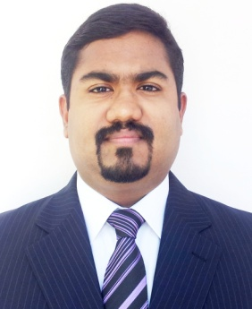 |  | dr. DEMPSEY MOHAN SAM
Profile  MALE  DATE OF BIRTH: 07.07.1987  PLACE OF BIRTH: Kuwait.  MARITAL STATUS: Married  PERMANENT ADDRESS:  Mukalukalayil House,  Omalloor via, Oonnukal P.O, Pathanamthitta,  Kerala-689647  PHONE NUMBER:  00919947730484 /  00918281243650.  EMAIL: dempseymohan@yahoo.com  NATIONALITY- Indian  RELIGION- Christian  LANGUAGES KNOWN– English, Malayalam, French, Hindi, Tamil, Arabic. |  | EDUCATION  SECONDARY SCHOOL: Jabriya Indian School, Kuwait.  Syllabus: CBSE, New Delhi.  Year Of Passing:2003  HIGHER SECONDARY /SENIOR SCHOOL:  Jabriya Indian School, Kuwait.  Syllabus: CBSE, New Delhi.  Year Of Passing: 2005  PROFESSIONAL QUALIFICATION  “M.B.B.S” (M.D. ‘PHYSICIAN’ ) : 2006 - 2012.  Medical University, Sofia, Bulgaria- E.U  “Fellowship In Diabetes”- 2016- 2017  Royal Liverpool & Broadgreen Medical University, U.K  “P.G Dip Infectious Diseases”- University of New South Wales, Australia ( Currently Pursuing)- 2018  LICENSES AND CERTIFICATION  Tranvancore Cochin Medical Council,  Registration No: 65481, Year: 2018.  Tamil Nadu Medical Council,  Registration No.:117495, Year: 2016.  Bulgarian Medical Association,  Registration No.(UIN): 2300012401, Year: 2012.  Professional training  University Hospitals-Sofia, Bulgaria  March –October 2011 (7 Months)  Apollo Hospitals, Chennai.  Clinical Rotations: June 2015 - May 2016 ( 1 year)  CONFERENCES, C.M.E & camps  ICMS (International Congress of Medical Students) 2007, Sofia, Bulgaria.  6th World Congress of Diabetes India 2015, Chennai.  Holistic Medical Camp & Rural Awareness Program 2015,  Thiruvallur Dist, Tamil Nadu.  The South Indian Artists Association Medical Camp 2016, Chennai.  Chief Ministers Multispeciality Mega Medical Camp 2016,  Secretariat, Chennai.

