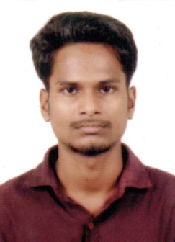
CURRICULAM VITAE
Libin kumar k k
2/2181-D,Dream villa
Civil station PO
Kozhikode – 673 020
Email: libinkumar13@gmail.com
libinkumar007@yahoo.com
Mob: 9446323215, 9809155369

PERSONAL PROFILE
Fsther’s Name : Lakshmanan k k
Date of Birth : 03/10/1990
Age : 26
Sex : Male
Marital Status : Single
Religion : Hindu
Nationality : Indian
Languages Known : English, Malayalam,Hindi

COMPUTER SKILL
- Tally Erp 9

WORKING EXPERIENCE
- One year trinee kerala sidco

EDUCATIONAL QUALIFICATION

SL  NO | COURSE | INSTITUTION | BOARD/ UNIVERSITY | YEAR | PERCENTAGE
1 | SSLC | Mcchss | Board of public examination, kerala | March 2006 | 50.7%
2. | Plus two | JDT Islam iqraa  Vellimadukunnu  Calicut | Board of higher secondary examination,  Kerala | March 2008 | 59%
4 | B.com | Devagiri ST.Joseph’s management institute | Calicut university | April  2015 | 51.2%
5 | Diploma in engineering | Kerla govt.polytechnic college westhill | Board of technical education of kerala |  | Persuing
6 | M.com | private | Calicut university |  | Doing

DECLARATION
I hereby declare that the above information furnished by me is true and correct to the best of my knowledge and belief.
Place: Calicut
Date: LIBIN KUMAR K K

