RESUME

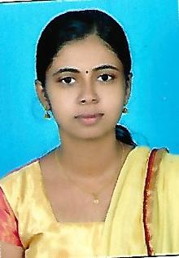
Name : SEERSHA.P
Age and date of birth : 22, 28th April 1996
Gender : Female
Religion : Hindu
Nationality : Indian
Permanent address : Punnathoor (HO)
Parakkottuthazham
Perumanna [P.O]
Pin 673019
Calicut
Phone number : 6282552236
Email Id : seershasivadas858@gmail.com
Academic qualification : Completed MSW [2016-2018] with specialization as
Rural and Urban Community development at
St. Joseph’s College [Autonomous] Devagiri, Calicut

Academic qualification | University/ board | Name of institution | Month and year of passing | Percentage of mark
MSW | Calicut University | St. joseph’s College [Autonomous] Devagiri | June 2018 | 70
B.A Sociology | Calicut university | Sree vidhyaniketan college, Calicut | March 2016 | 76
Plus two | Kerala state board of education | GHSS kuttikkattoor | March 2013 | 75
SSLC | Kerala state board of education | GHSS kuttikkattoor | March 2011 | 78

Language skills : Malayalam, English
Professional skill : Effective communication skills, Presentation skills, Public speaking, Documentation skills, Time management, coordinating skills
Internships and participation in various programs:
- Undergone internship at KESS- KARE [HIV-AIDS care and support project], Peruvayal, Kozhikode from 29th November 2016 to 18 December 2016
- Undergone internship at KIDS [kottapuram integrated development society] Thrissur from 3rd April 2017 to 3rd May 2017
- Done internship from 3rd October 2017 to 27th October 2017 at ECHO [Empowerment of Children Human right Organization) kammanahalli, Bangalore
- Undergone internship at NAWA [Nilgiri Adivasi Welfare Association], Kotagiri, Ooty from 1st January 2018 to 31st January 2018
- Participated in a participatory rural appraisal workshop conducted from 10- 12 February 2018 by dept. of social work, St. Joseph’s college [Autonomous] Devagiri in association with STARS Calicut

