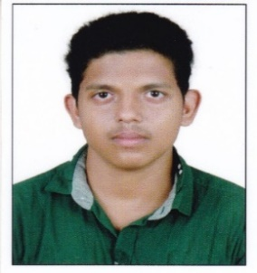
AKHIL M Mobile No : +91 8848356939, +91 7293582619
Email id : akhil.mohanm16@gmail.com

JOB Objective:

Seeking position as a Fire Safety Officer with a reputable organization in which my skills and knowledge can help further the development of the organization.

PROFILE SUMMARY:

- Worked as a Safety Officer Trainee in KMML, Kerala.
- Worked as a Junior Safety Officer in E-Movers Private Limited, Dubai, United Arab Emirates

ORGANISATIONAL EXPERIENCE:

KMML (Kerala Minerals and Metals Limited) Chavara, Kerala
E-Movers Private Limited, Dubai

EDUCATION:

2017 DIPLOMA IN FIRE & SAFETY, NIFE, Kollam
2017 BA Political Science, Indira Gandhi Open University, SN College Kollam (Distance Education) - Doing

TRAINING / CERTIFICATIONS ATTENDED:

2018 IOSH - Institution of Occupational Safety and Health, UK Based.

PERSONAL DETAILS

Date of Birth : 18th February,1997
Residential Address : Melathil Veedu, Bhoothakulam P.O, Paravur, Kollam-691302.
Languages Known : English, Hindi and Malayalam
Passport No. : N 1503776

Professional Experience: (1.3 years)

Organization #1

Organization name: KMML (Kerala Minerals and Metals Limited) Chavara, Kerala
Period: 1st June 2017– 30th August 2018
Role: Safety Officer Trainee

Responsibilities:

- Performed regular inspections of all planes and aviation facilities.
- Complied with all local and state aviation safety regulations.
- Prepared detailed reports identifying potential fire safety issues.
- Investigated fires explosions and other unexpected fire-related emergencies.
- Tested and installed required fire safety equipment.
- Ability to work hard autonomously as well as in a team.
- Comprehensive problem-solving capability with sharp decision making ability.

Organization #2

Organization name: E-Movers Private Limited, Dubai, United Arab Emirates
Period: 7th September 2017 – 6th September 2018
Role: Junior Safety Officer

Responsibilities:

- Inspected warehouses and other corporate facilities
- Coordinated with management to develop cost-effective solutions for correcting issues
- Performed routine fire safety inspections of private and city-owned buildings.
- Adoptability, Flexibility, hardworking and open-minded.
- Goal Oriented Planning and Execution Capabilities.
- Confident with creative abilities and good communication skills.
- Can adopt sudden changes and flexible enough to work inside any team
- Prepared reports detailing the results of each inspection.
- Checked all fire safety equipment to determine that everything was functioning.
- Recommended methods to correct all identified fire safety violations.
I hereby declare that the details given above are true and correct to my knowledge and belief.

AKHIL M

