CURRICULUM VITAE
AMALU ASHOK  ASHOKALAYAM (H)  MOOTHEDATHU KAVU  T.V. PURAM P.O, VAIKOM  KOTTAYAM – 686606  Mob: 8289881149,8593082240 Email: amaluashok2581995@gmail.com | 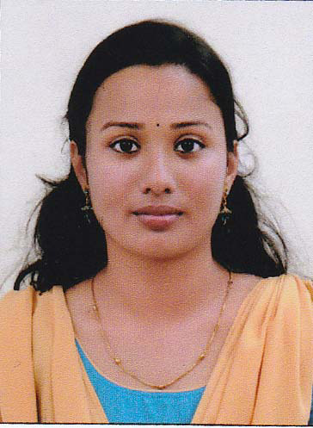

CARRIER OBJECTIVE
To build a carrier in Health Information Management with a reputed organization where I can exercise my skills and abilities and achieve professional growth while being resourceful, innovative and flexible.
SKILL SUMMARY
- Medical Record Management
- Open and Closed review for JCIA
- Open and Closed review for NABH
- Able to work in EMR and manual systems
- Trained in ICD-10,ICD-O and ICPM
- Quantitative analysis of documentation
- Preparation of Hospital statistics
- Practical knowledge
- Sorting & filing of medical records
- Assembling
- Review of consents
- Word processing
- Computer knowledge in windows

PROFESSIONAL QUALIFICATION
MSC in Medical Documentation from Mahatma Gandhi University Kerala
PROJECT WORK
Project work titled `` An analytical study of Medical record Documentation Standards and performance in EMR for improving the quality of care in Aster Medcity kochi ``

PERSONAL SKILLS

- Ability to rapidly build relationship and setup trust
- Good communication skills
- Time management
- Confident and determined
- Ability to cop up with different situations
- Hardworking
- Self confidence

ACADEMIC CREDENTIALS

SI No. | Name of Course | Year | Name of Institution | Name of University/Board
1 | MSC Medical Documentation | 2016-2018 | Centre for Professional & Advanced Studies  Kottayam  (School of Medical Education, Gandhinagar.) | M.G. University  (Centre for Professional & Advanced Studies)  Kottayam
2 | BSC Physics | 2013-2016 | St. Xavier’s College, Vaikom | M.G.University
3 | PLUS TWO  (Science) | 2011-2013 | St. Little Theresa’s Girls Higher Secondary School, Vaikom | HIGHER SECONDARY BOARD
4 | SSLC | 2010-2011 | ,, | Kerala Board of Public Exam.

ACHIEVEMENTS
- Got B2 grade on Aptis exam (Forward thinking English Testing ) conducted by British Council
- Certificate course in C programming from G-TEC Computer Education with A grade
- Certification in Banking & Finance conducted by IQAC

- Participated in Madhava Mathematics Competition held on jan 5,2014 organized by Homi Bhabha Centre for Science Education ,TIFR,Mumbai

- Participated in National Seminar in Vibrational Spectroscopy at St.Xaviers College ,Vaikom during 2016 sponsored by UGC
PERSONAL PROFILE
Name : Amalu Ashok
Age : 23
Date of birth : 25.08.1995
Gender : Female
Nationality : Indian
Mother tongue : Malayalam
Marital status : Single
Religion & caste : Hindu, Ezhava
Language Known : Malayalam, English, Hindi & Tamil
Name of guardian : Ashok Kumar E.G
Permanent address : Ashokalayam (H)
Moothedathukavu
T.V Puram p.o
Vaikom ,Kottayam
Pin : 686606
Mob. No : 8289881149
Email id : amaluashok2581995@gmail.com

Communication address : Ashokalayam (H)
Moothedathukavu
T.V Puram p.o
Vaikom ,Kottayam
Pin : 686606
Mob.no : 8289881149,8593082240
Email id : amaluashok2581995@gmail.com
ACTIVITIES
Actively participated in NSS during college level
PROFESSIONAL EXPERIENCE
- Had undergone 2 month internship at Aster medcity Hospital kochi during the period 29/8/2018 to 29/10/2018
- Ten days experience in the same field as a trainee in Regional Cancer Centre, Thiruvananthapuram.
- Ten days experience in W & C Hospital, Thycaud, Thiruvananthapuram
- Ten days experience in General Hospital, Thiruvananthapuram
- Undergone Twenty days internship of departmental study in Thiruvalla Medical Mission Hospital, Thiruvalla
- Ten days experience in Carithas Hospital, Kottayam.
EXPOSURE IN MEDICAL DOCUMENTATION FIELD:
- Participated in National Medical Records Conference named “Medrecon 2017” on 4th & 5th February 2017 at G. Kuppuswamy Naidu Memorial Hospital, Coimbatore.
AREAS OF INTEREST:
- EMR
- Medical coding
- Constructing Medical Records Department

REFERENCE

Suma V Madhavan
Head of the Department of the Medical Documentation
School of Medical Education,
Gandhinagar
Kottayam, Kerala.
Pin: 686008
Ph: 09447414208
DECLARATION
I hereby declare that the information provided above is true to the best of my knowledge and belief.
Place: Kottayam AMALU ASHOK
Date:

