RESUME

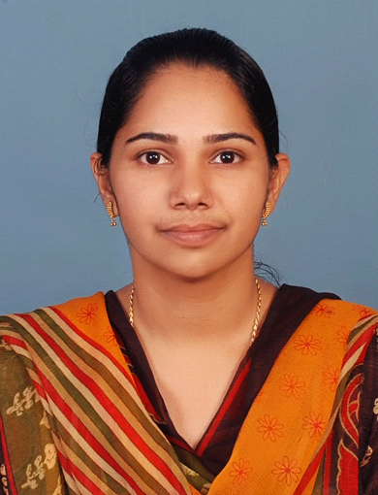

BETREENA BABY

Betreena Baby
F1/2 Shipyard Quarters
Panampallinagar
Ernakulam 682036

Mob: +91-7907076933, 9446493410
E-mail - betreena@gmail.com

I am a 35 year old graduate (B.Sc Zoology). I followed the State syllabus for my primary education and have graduated from Alphonsa College Pala under Mahathma Gandhi University, Kerala. At present I’m working as an Ultrasound In-charge + Senior Medical Transcriptionist at Vivid Diagnostic Center, Chalikkavattom, Vytilla, Kerala.

I would like to deliver my skills and passion for the mutual benefit and the continuous association with the organization in its growth.

TRANSCRIPTION SPECIALTIES:
Transcribing capability of over 550 lines per shift with accuracy of +99%.
Over 12+ years of experience in transcription. Experienced in all specialities.
Fair auditory and keyboarding skills.
Typing speed of 50-60 wpm.
SKILLS & STRENGTHS:
Over 12+ years of in-depth experience in Medical transcription. Worked on computerized system of transcribing patient reports. Working as a patient coordinator.
Dedication and drive as a hard-working individual.
Ability to manage multiple tasks in a pressured environment.

PROFESSIONAL EXPERIENCE:
- Vivid Diagnostic Center June 2017---Present
Senior Medical Transcriptionist +Ultrasound In charge
2. Systems & Software Solutions, Ernakulam (HT)
Senior Medical Transcriptionist 2006 -- 2017
3. M-Squared Software Developments and Exports Pvt Ltd
Medical Transcriptionist June 2004 – July 2006
EDUCATIONAL QUALIFICATIONS:
Medical Transcription Course – (6 months) M-Squared Software Developments and Exports Pvt Ltd (2004)
B.Sc. in Zoology, 2000-2003 From Alphonsa College (Mahathma Gandhi University) 75%.
Pree Degree Science 1999-2000 From St. Xaviers College Aluva (Mahathma Gandhi University)
SSLC 1998 From SNVHS N R city (State) 80%.
PERSONAL DETAILS:
Father’s Name: O. K. Baby
Date of Birth: June 29, 1983
Marital Status: Married
Nationality: Indian
Interests: Music, Gardening, cooking.
Languages Known: English, Hindi, Malayalam
DECLARATION:
I hereby declare that the information mentioned above is correct to the best of my knowledge. I look forward to hearing from your esteemed organization at the earliest.
Place : Ernakulam
Date : 26/09/2018

BETREENA BABY

