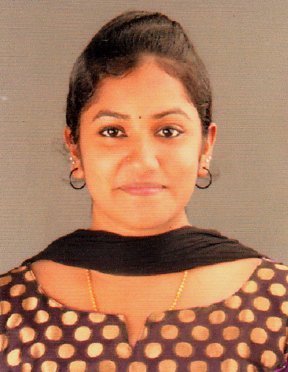
Ruby P Jacob

Elanjickal (H), Piralassery P.O
Chengannur, Alappuzha, Kerala
+91-8921147613
rubypjacob02@gmail.com

PHYSIOTHERAPIST

OBJECTIVE: To work with a center of therapy that give a chance to improve knowledge and skills as a physiotherapist and climb up the ladder of success along with taking my organization to height of Popularity and Respect.

ACADEMIC/ PROFESSIONAL QUALIFICATIONS:
- S.S.L.C – Metropolitan Higher Secondary School, Puthecavu

- H.S.C – Vocational Higher Secondary School, Aranmula

- Bachelors in PHYSIOTHERAPY – Alva’s College of Physiotherapy, Mangalore
INTERNSHIP

- Orthopedic Exposure in : TEJASWINI Hospital (ICU, Post-Operative Department)

- Neurology & Neurosurgery in: First Neuro Hospital and Mallikhatte Neuro Center, Mangalore

- Orthopedics and Sports Rehabilitation : Alva’s College of Physiotherapy

- Community based Rehabilitation and Geriatrics

- Emergency/ Casualty Department: Alva’s Health Center

- Neuro-Physiotherapy and Rehabilitation: Alva’s College of Physiotherapy

- Cardio-Respiratory

- Neuro-Pediatric Department: Alva’s College of Physiotherapy

CERTIFICATIONS
- Certification in Indian Academy of Fitness Training in Pre & Postnatal Instructor

- Certification in Indian Academy of Fitness Training in Diet & Nutrition Instructor

- Certification in Indian Academy of Fitness Training in Aerobics Instructor

- Certification in Indian Academy of Fitness Training in Primary and Advanced Pilates Instructor

- Certification in Indian Academy of Fitness Training

- Certification in Indian Academy of Fitness Training in Advanced Gym/ Fitness Instructor

- Certification in National Conference “ RECENT DEVELOPMENT IN ORTHPEDIC SURGERIES & UPDATE IN REHABILITATION & RESEARCH”
WORKSHOPS

- Basics of Manual Therapy

- Two Dimensional Video Analysis and Science of strength training in sports-practical demo
PRESENTATIONS

- “Frontal Plane Analysis of Gait” : Alva’s College of Physiotherapy

- “ Phases of Pulmonary Rehabilitation” : Alva’s College of Physiotherapy
KEY SKILLS & STRENGTHS:

- Ability to manage risks & issues
- Experience in dealing with Emotional and Stressful situations
- Ability to motivate others through effective communication skills
- Awareness in Fire, Health & Safety and Departmental Policies
- Organizing and prioritizing own workload & delegating responsibilities accordingly
- Ensuring that the equipment’s used in carrying out Physiotherapy procedures are safe
- Involvement in ward rounds, meeting and conferences
- Prioritizing urgent referrals and emergency cases
- Excellent oral and written Communication skills
HOBBIES:
- Singing, Dancing, Yoga, Hand-crafts, Badminton
PERSONAL INFORMATION
Date of Birth: 24thMarch, 1994

Marital Status: Single

Nationality: Indian

Sex: Female

Relegion: Christian

Languages Known: English, Hindi, Tamil, Kannada, Malayalam

DECLARATION:
I hope you will find my experiences suitable for your esteemed organization and if given an opportunity, I will put all my efforts to work hard in serving the organization and in gaining knowledge.

Thanking you,

Ruby P Jacob
+91-8921147613

