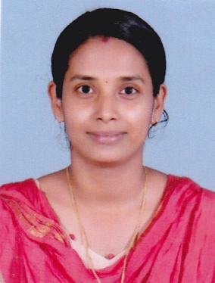
VIJI.V
W/o AntonyNetto
Tharazhath House
Kodamthuruth
Kuthiathode.P.O.
Cherthala
Alappuzha-688533

Mob : 9072614922
E-mail : vijivvk888@gmail.com

PROFESSIONAL SUMMARY

- A register Pharmacist with 3 and half years of experience in both the public and private sectors.
- Committed professional with a genuine interest in improving patient experience
and customer service focused on compliance
- A fully qualified Pharmacist able to prescribe certain medications and experienced in training and supervision tasks. Now seeking to put my broad ranging expertise to use I the private sector and to further develop my team management and training skills.
CORE QUALIFICATION

- D-PHARM (Diploma in Pharmacy)
SNGM Pharmacy College, Valamangalam.P.O,Thuravoor (2010-2012)
- Directorate of Medicine Education (DME)
- Registered under Kerala State Pharmacy Council

ACADEMIC QUALIFICATION

Name of the Course | Board/Institution | Year of Passing
D-Pharm  (Diploma in Pharmacy) | SNGM Pharmacy College  Valamangalam.P.O, Thuravoor | 2013
Plus Two | Our Lady of Mercy HSS, Aroor | 2010
S.S.L.C | Our Lady of Mercy HSS, Aroor | 2008

MY SKILLS

- Comprehensive clinical awareness through understanding of best prescription and pharmacy practices.
- Excellent interpersonal and team management skills
- Extensive knowledge of multi compartment compliance aid management in the workplace
- Proficient user of IT or point of sale terminals

WORK EXPERIENCE

- Pharmacist - Sreehari Medicals, Thuravoor
Mob: 9947188449
April 2015 to Present
- Hospital Pharmacist (Dispensing) - General Hospital, Ernakulam
(3 Months)
- Hospital Pharmacist (Trainee) - General Hospital, Ernakulam

HOBBIES & INTERESTS

- I am extremely interested in the development of procedures to counteract prescription drug addiction and to keep medications safe from patients that would abuse them.
- I enjoy reading books and listening music

PERSONAL DETAILS

Age & DOB : 26, 08/06/1992
Husband’s Name : Antony Netto
Sex : Female
Religion, Caste : Christian, Roman Catholic Anglo Indian
Nationality : Indian
Marital Status : Married
Languages Known : English, Malayalam and Tamil
Contact No. : 8129949337, 9072614922
E-mail : vijivvk888@gmail.com

DECLARATION

I hereby declare that the above furnished details are true to the best of my knowledge and belief.

Place : Kuthiathode
Date : VIJI.V

