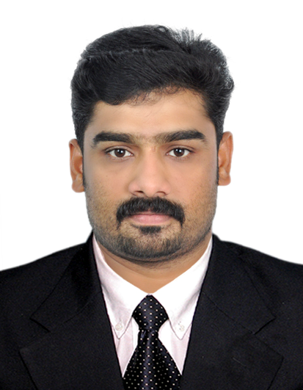

Sumesh Melethil

Present Address Permanent Address
P.O Box 2716 Melethil House
Dubai – U.A.E. Vettikkattiri
Mob: 050-9148962 Vettikkattiri (P.O) Thrissur
E-mail: smsumeshsafety@gmail.com Kerala - 679531

OBJECTIVE : Administrative career in a productive organization concerned about the safety of its employees wherein my educational qualifications and organizational abilities are effectively brought into play. Maximize capabilities in a challenging and productive environment.

working experience

Currently Assigned
As a Sr. EHS Officer ➢ For Apex Experts Contracting LLC
Working in Dubai Creek and Harbour Project
From 11th December 2017 to till date

Previous Experience

As a Safety Officer ➢ Khansaheb Civil Engineering L.L.C., Dubai, U.A.E
A reputed construction company, in collaboration with Interserve
Group of Companies and ISO 9001 & OHSAS 18001 certification

From 7th January 2009 to 14th November 2017.

As a Safety Officer ➢ Salarpuriya Construction Company (Bangalore, India)
From 1st August 2007 to 28th February 2008

JOB RESPONSIBILITIES
- Site Inspections: - Daily.
- Documentation and Data / Records control.
- Prepare Health & Safety Statistics as per the requirements
Of the Consultant.
- Accidents & Incident Reporting, Investigation.
- Identifying Hazards and make solution to solve it.
- Fire Prevention and Emergency Evacuation Procedure
- Inspection of portable Firefighting equipment.
- Inspection of Lifting Appliances and Accessories.
- Inspection of Hand Tools and Power tolls.
- Issuing Hot work permits.
- Inspection of Scaffolding and Working platforms.
- Conduct Safety Induction and Toolbox Talks.
- Risk Assessment.
- Maintain First Aid facilities.
- Safety Audit.
- Documentation as per the OSHAS standard.

PROJECT WORKED

PULLMAN HOTEL @ MALL of the EMIRATES
CLIENT: - MAJID AL FUTTAIM
CONSULTANT: - NOOR
From 7th January 2009 to 30th July 2010
➢ Worked in ‘Wild Wadi Water Park’

CLIENT: - JUMEIRAH INTERNATIONAL LLC

CONSULTANT: - WS ATKINTS

From 1st August 2010 to 5th December 2010
- Worked in ‘ 85/2010 Construction and Road Maintenance Infrastructure Improvement’

CLIENT: - MINISTRY OF PUBLIC WORK

CONSULTANT: - IDROESSE

From 5th December 2010 to 20th September 2011.

Worked in ‘ Fujairah City Centre Project ’
CLIENT: - MAJID AL FUTTAIM

CONSULTANT: - HYDER CONSULTANCY

From 25th November 2011 to 31st March 2012.

Worked in ‘PALM JUMEIRAH SOFITAL RESORT’
CLIENT: - MIRK General Trading L.L.C

CONSULTANT: - MIRK CONSULTANCY

From 1st April 2012 to 20th March 2013.

Worked in Khansaheb Metals Division As an EHS OFFICER.
From 5th MAY 2013 to 31st March 2015.
Worked in Beach Palace Phase II As an EHS OFFICER.
From 1st April 2015 to December 2015.
Worked in Dry Storage Facility at Dubai International Marine Club As an EHS OFFICER.
From 1st January 2016 to April 2016.
- Worked in Serenia Residences @ Palm Jumeriah As an EHS OFFICER.
From 5th April to 20th November 2017
- Working in Dubai Creek Harbour Project As Sr. EHS OFFICER.
From 11th December 2017 to till date.

Educational QUALIFICATIONS:

- BA (Economics )

proffesional QUALIFICATIONS:

- Diploma in Fire & Safety Engineering
National Institute of Fire Engineering, Kochi, Kerala: (2007)

- NEBOSH International General Certificate

(Conducted By PARSONS BRINCKERHOFF)

- Certificate in OSHA (Occupational Safety & Health Administration)
From US Department of labour

- Emergency First Aid Training Certificate
St John’s Ambulance, Red Cross India: (2007)

- U.A.E. Valid Driving License

Trainings undergone

- Health & Safety for Safety Officers Conducted by Interserve
Group of Companies. (UK) at Dubai, U.A.E (March 2010)
- International Basic First Aid Course (UK Standard) Conducted
By Euro link Safety Services, at Dubai, U.A.E (September 2010)
- Basic Fire Fighting Course Conducted by Euro Link Safety Services, at Dubai. U.A.E (December 2010)
- International Basic First Aid Course (UK Standard) Conducted
By Euro link Safety Services, at Dubai, U.A.E (July 2013 & December 2016).

COMPUTER PROFICIENCY ➢ Diploma in Computer Application
Good & speed in typing.
- Knowledge of MS Office.

PERSONAL details:

Name of Father : Surendran.M
Languages Known : English, Hindi, Malayalam & Tamil.
Visa Status : Employment

declaration : I hereby declare that all stated information’s are true to the best of my knowledge and belief.

Place: Dubai
Date:18.09.2018
(Sumesh.M)

