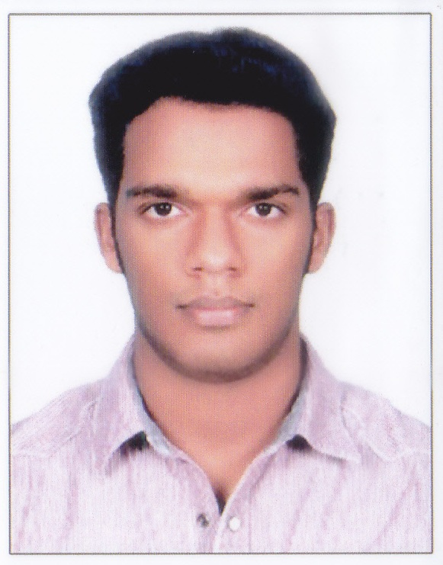

Name: |  |  | Anandu S
Address: |  |  | Sreesadan Karakkad PO Chengannur  Alappuzha PIN 689504
Mobile: |  |  | 9496808177
E-Mail: |  |  | anandusofficial@gmail.com
CAREER OBJECTIVE
Attain the post of Radiographer to deliver my expertise interpretation skills for the various radiographic findings, to make an impact for quick and accurate treatment of patients by a thorough understanding of diseases.

EDUCATION

Jawaharlal Institute Of Postgraduate Medical Education And Research 08/2015-07/2018
Bachelor of Science (Medical Technology Radiodiagnosis)

- Percentage – 76%
- Language – English
- Specialized subjects- Anatomy, Physiology, Pathology, Microbiology, Basic Nuclear and Radiation Physics, Image Processing Techniques, Physics of Diagnostic Radiology, Interaction of Radiation with Matter, Radiation Measurements,Quantities and Units, Radiographc procedure and positioning, Special radiographic procedures, Advanced Imaging, Radiation Safety in Diagnostic Radiology, Regulatory Requirements in Diagnostic Radiology.

Central Board of Secondary Education,India 06/2013-04/2014
All India Senior School Certificate Examination(Plus Two)

- Percentage – 88%
- Language – English
- Specialized subjects – Physics, Chemistry, Biology, Computer Science, English.
Central Board of Secondary Education,India 06/2011-04/2012
All India Secondary School Examination(Tenth)

- CGPA-10
- Language – English
- Specialized subjects – Science (Physics,Chemistry,Biology), Mathematics, Social Science, English, Malayalam.

SKILLS
- Assess patients and their clinical requirements to work out which radiographic techniques to use;
- Perform a range of radiographic examinations on patients to produce high-quality images;
- Take responsibility for radiation safety in your work area, including checking equipment for malfunctions and errors;
- Manage referrals to ensure patients receive a radiation dose as low as reasonably possible;
- Supervise visiting staff and patients in radiation work areas;
- Help in more complex radiological examinations, working with doctors such as radiologists and surgeons;
- Provide support and reassurance to patients, taking into account their physical and psychological needs;
- Supervise radiography and imaging support assistants;
- Keep up to date with health and safety guidelines, including ionising radiation regulations, to protect yourself and others.
- IT skills.
- A high level of emotional intelligence to manage the emotional and distressing situations you may encounter.

TRAINING EXPERIENCE
- Completed diagnostic radiographic procedures in the radiology department of a 2300-bed teaching hospital.
- Perform MRIs, CT scans, X-ray imaging, portable radiography and fluoroscopic procedures.
- Serve a diverse caseload including newborns, infants, children, adolescents, adults and geriatric patients.

SKILL NAME | MACHINE | EXPERTISE LEVEL
X-RAYS | CARESTREAM 120MA  ALLENGERS 100MA | EXPERT
COMPUTED TOMOGRAPHY | SIEMENS SOMATOM SPIRIT 2 SLICES,32 SLICES  PHILIPS BRILLIANCE 6 SLICES | EXPERT
MAGNETIC RESONANCE IMAGING | SIEMENS MAGNETOM AVATO 1.5 TESLA | INTERMEDIATE
- Basic knowledge in Interventional Procedures, Cath Lab Procedures and Nuclear Medicine Procedures.

LANGUAGE SKILLS

- English
- Malayalam – Mother tongue
- Tamil – Intermediate Knowledge
- Hindi – Basic Knowledge
BASIC DETAILS

NAME | ANANDU S
GENDER | MALE
DATE OF BIRTH | 06/07/1996
NAME OF FATHER | SASIKUMAR C
NAME OF MOTHER | SREELEKHA S
MARITAL STATUS | SINGLE
NATIONALITY | INDIAN

CONFERENCES
- Participated in Scientific Meet “Techaspire 2016”, an Update for Technologists conducted by GE healthcare on 24th April 2016 at Puducherry.
- Participated in continuing medical education (CME) & workshop on “CT & MRI In Practice” conducted by Mother Theresa Post Graduate & Research Institute of Health Sciences on 20th November 2016 at Puducherry.
- Participated in continuing medical education (CME) & workshop on “Radiation Quality and Safety Training” conducted by JIPMER Quality Council (JQC) on 4th May 2017 at JIPMER, Puducherry.

REFERENCES

Dr. A Ramesh  Additional Professor &  Head of Department  Department of Radiodiagnosis,  JIPMER, Puducherry.  Mobile: +91 94891 47871  Email: dr_rameshrad@yahoo.co.in | Dr. Deepak Barathi S  Associate Professor  Department of Radiodiagnosis,  JIPMER, Puducherry.  Mobile: +91 99945 48872  Email: deepakbarathi@yahoo.com
Dr. Sunitha V C  Associate Professor  Department of Radiodiagnosis,  JIPMER, Puducherry.  Mobile: +91 94891 46561  Email: sunithapradeepnair19@gmail.com | Dr. Subathra A  Associate Professor  Department of Radiodiagnosis,  JIPMER, Puducherry.  Mobile: +91 76394 09447  Email: subathra26@gmail.com

