RESUME
ANUSREE . P.D 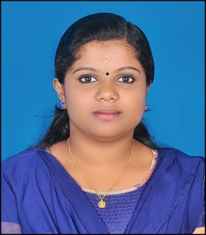
PURATHOOTU(HO)
PUTHUSSERIKADAVU (PO)
PUTHUSSERIKADAVU
WAYANAD, KERALA
PIN: 670645
MOB: 9526279417
E-MAIL: anusreepd333@gmail.com

CAREER OBJECTIVES:
To be associated with a reputed Hospital, where I can use my knowledge and creative skills to the best and thereby giving full effort for the development of the organization and giving service to the society.

AREA OF EXPERTISE:

- Pharmacy
- computer

EDUCATIONAL QULIFICATION:

SL NO. | NAME OF THE  COURSE | YEAR & MONTH OF PASSING | PERCE  NTAGE | INSTITUTION
1 | B.Pham | MAY - 2018 | RESULT WAITING | JDT ISLAM COLLEGE OF PHARMACY ,KOZHIKODE
2 | PLUS TWO | MARCH – 2013 | 88 | SACRED HEART H.S.S DWARAKA,MANANTHAVADI
3 | S.S.L.C | MARCH – 2011 | 90 | SACRED HEART H.S DWARAKA,MANANTHAVADI

STRENGTHS:

- Confident & determined
- Ability to cope up with any situations

INTERESTS:
- Cooking
- Travelling
- Rendering service to the society

PERSONAL DETAILS:

Father’s Name : Dileep Kumar P.S
Date of Birth : 16/05/1996
Sex : Female
Religion & Cast : Hindu, Ezhava
Marital Status : Single
Nationality : Indian
Languages : Malayalam, English
Blood Group : A+

DECLARATION:

I hereby declare that all the above mentioned data is true to the best of my knowledge and belief. I am sure that my potentials can come up in an organization like yours. I can prove my worthiness to the organization, if given a chance.

Place: Puthusserikadavu
Date: ANUSREE P.D

