ARUN M
TC 31/1082,  Thunduvilakkathu veedu,  Parakudi Lane, Pettah P.O  Trivandrum, Kerala-695024  India  Mobile: 7034573120  Email: arun.m7736@gmail.com | 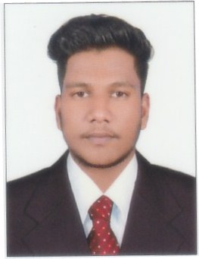

Career Objective
To utilize my competency and creative perspective in my own personal development and in the development in the organization.
Academic Backgrounds
- Higher Secondary Examination in Science from St Joseph’s H.S.S, Trivandrum
- SSLC from St Mary’s Higher Secondary School, Pattom, Trivandrum
Professional Qualification
- Diploma in CSSD Technology from KIMS Trivandrum, Kerala, India.
Co-Curricular Activities
- Participated in one day training on State Sterilization & Disinfection Congress. Organized by the State Sterile Processing Professional Society (SSPPS)
Job Knowledge
I can arrange independently trays for procedures and also known to make all the linen packs and dressing materials required for surgeries and ward procedures.
I can operate the following machine independently
- J&J STERRAD Plasma Sterilizer
- 3M Steri Vac ETO Sterilizer
- GETINGE Steam Sterilizer
- CISA Steam Sterilizer
- CISA washer
- NAT STEEL Steam Sterilizer
- Flash sterilizer
- GETTING Band Sealer
- GETTING Washer
- 3M Sealer
- MACHIN FABRIK Ultrasonic Machine
- Beston Incubator
Personal Strengths
- Problem solving abilities & Good analytical skill.
- Can work under pressure and deadliness.
- Ability to work as part of a team or as an individual.
- Excellent communication skills, interpersonal skills and calm personality.

Personal Profile
Date of Birth : 08/07/1997
Age : 21
Sex : Male
Nationality : Indian
Religion & Caste : Hindu, Thandan
Marital Status : Single
Languages Known : Hindi, Malayalam, English
Father’s Name : Maniyan. M
Hobbies : Reading, Playing Cricket

Declaration
I hereby declare that the information furnished above is true to the best of my knowledge and I bear the responsibility for correctness of the above-mentioned particulars.

Place: Trivandrum
Date : Arun M

