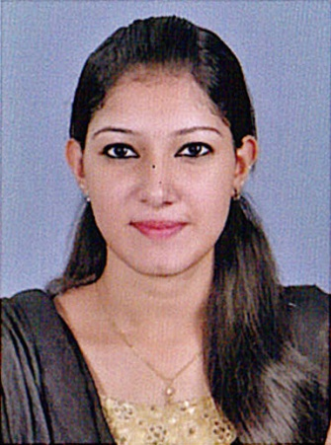

NANDANA VALSAN
nandanava143@gmail.com
+919746553407

CAREER OBJECTIVE

To make positive impact in my field of activity leading to organization growth by creative application of my value based convictions and professional divinity by putting my all efforts in the work assigned to me in an organization where I can grow along with the organization.

PERSONAL STRENGTH

- Strong Interpersonal organizational skills
- Sincerity towards job and punctuality
- Able to cope under pressure
- Very meticulous and versatile
- Excellent communication skills
- Can work independently or as a part of team

ACADEMIC QUALIFICATIONS

- SSLC
De Paul Public School , Idukki
Central Board of Secondary Education

- 12th
National School , Pathanamthitta
National Institute of Open schoolling

- BA ENGLISH (2 supply)
Sienna College Of Professional Studies , Edakochi
Mahatma Gandhi University , India

- CERTIFICATE PROGRAMME IN MANAGEMENT (At present) (distant edn.)
National institute of business management
Kingster Education,ISO 9001:2008,Certificate of International Accreditation

- MBA IN AIRPORT & AIRLINE MANAGEMENT (At present) (distant edn.)
National institute of business management
Kingster Education,ISO 9001:2008,Certificate of International Accreditation

WORK EXPERIENCE

- Worked in a Recruitment firm for 3 months

- Worked as a TME in an MNC for 4 months

PERSONAL PROFILE

- Name : NANDANA VALSAN
- Marital Status : SINGLE
- Address : NANDANAM
S N D P ROAD , KUMBALAM FERRY ,
EDAKOCHI , PIN - 682010
- Nationality : INDIAN
- Date of Birth : 27 – 09 - 1996
- Gender : FEMALE
- Religion : HINDU
- Languages Known : ENGLISH ,MALAYALAM

DECLARATION

I hereby declare that all the above mentioned statements are true and correct to the best of my knowledge and belief .

Place : EDAKOCHI
Date :
(NANDANA VALSAN)

