CURRICULUM VITAE
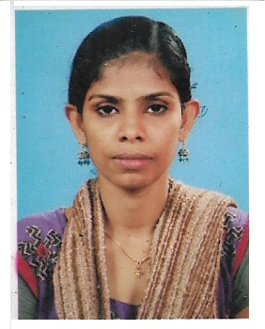
Jishamol V S
Ruby Hall Clinic
Medical Surgical Departement
Pune
Mob :- 9067181737
Email : jishajithin55@gmail.com

Career Objective
To secure a position as a registered nurse in a dynamic and challenging acute care setting where I can continue to develop my skills in patient advocacy and collaborative practice.
Educational Qualification
Education | Name of Institution | University /Board | Passing year | Percentage
Bsc. Nursing | Victory college of nursing | Rajive Gandhi of University of Health Sciences | April 2014 | 76%
Plus Two | Govt. Regional Fisheries Technical Vocational Higher Secondary School | Vocational Higher Secondary School | March 2009 | 78%
SSLC | SDPY VHSS | Kerala Board | March 2007 | 70%
Professional experience
Position | Hospital | Duration | Job Description
Staff Nurse | Ruby hall Clinic, Pune, Maharashtra, 411001` | 13th Oct 2015 to till date | Medical Surgical Department

Experience Details
I had 2 years 3 months experience in medical surgical department.
Registration state | Registration no.
Karnataka | 070089
Kerala | KL04201802032

Job Description
- Staff nurse in Medical Surgical Department of Ruby Hall Clinic Pune Maharashtra, India
- provides care for adult and children requiring appropriate medical aids.
- Providing cardiac pulmonary resuscitation.
- Administer narcotic drugs.
- Assisting procedure like PICC Insertion intercostal drainage, lumbar puncture, bone marrow aspiration, central line insertion, asceptic tapping.
- Preoperative and post operative care.
- Performing procedure like insertion of post cab.
- Utilities standard and specialized equipments.
- Deliver care in accordance with latest professional standards .
- Administration of oral and parenteral medications .
- Documents variations in patient conditions and associated nursing care in nursing progress notes .
- Admission and discharge procedures .
- Competent in applying the principles of medical asepsis and concurrent .disinfections.
- Develop and initiates innovative teaching program.
- Experienced In Using Following Instruments
- Cardiac monitors , glucometer ,pulse oxymeter , nebulizer
- IV infusion , and syringe pump
- Bio safety cabinet
- Ecg machine
- Sphygmomanometer
- Crush trolly
- Suction apparatus
- Laryngoscopes

PERSONAL INFORMATION
Name : Jishamol V.S
Father Name : V.P Shaji
Date Of Birth : 09/11/1991
Sex : Female
Marital Status : Single
Nationality : Indian
Religion : Hindu
Present Address : Valavipparambil House
Edakochi , Pambaimoola
Permanent Address : Valavipparambil House
Edakochi, Kochi 682 010
Mobile Number : 9067181737 , 7907666645
Email id : jishajithin55@gmail.com
Languages known : malayalam , english , hindi , kannada
Declaration
I here by that the above information is true to the best of my knowledge and beliefs
Place : Edakochi
Date :

JISHAMOL V S

