Curriculum Vitae
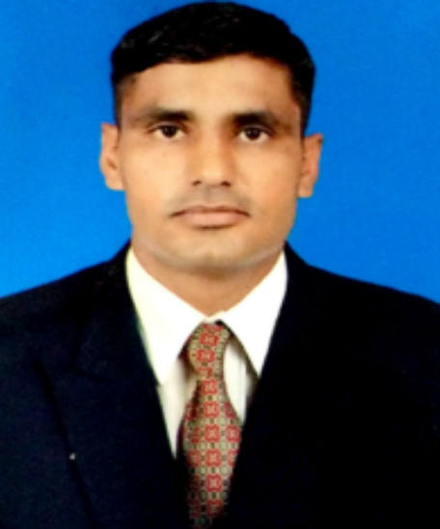
VINOD SINGH
MOB. – +91 8469048444
E-mail id – vsvinods90@gmail.com
Courses:
- Air Diver IIIrdclassin from Indian Navy(Diving School Kochi) India
- Air Diver 1^{stclass}(Dive Master)from Indian Navy (Diving School Kochi) India
- Basic modular Fire Fighting course.
- Training Technology course (Instructor course) from NIETT India
- Ordnance / Explosive Handling course from NSG Manesar India
- Diploma in Security & Banking from Cardinals educational society Hyderabad.
- Diploma in Leadership & Management from Hyderabad.
- First Aid Medicine and Physiology phase in INM Mumbai.
- Air Diving Supervisor, Kochi
Personal details:
- Date of Birth 17 Nov 1984
- Nationality Indian
- Marital Status Married
- Education Qualification Graduate
- Passport Number R 2656475
- Passport Validity 24 Aug 2027
- Languages Known English, Hindi

- Address Vinod Singh
VPO- Barhana ,Tehsil -Beri
Distt – Jhajjar , Haryana -124107

Relative Experience

Security Management – (a) Planning and monitoring industrial security arrangement involving preparing security plans & deploying security personnel.
(b) Formulating SOPs and implementing stringent security systems to establish and maintain high security standards, includind fire fighting techniques, first aid and other safety measures.

Team Management and Motivation - (a) Possess strong communication, collaboration and team building skills. (b) Trained and instructed to have a high sence of commitment and strives for the achievement of excellence.
(c) A team player, with the ability in delegating people with complementary skills for maximum team effort and effectively draws on the strength of all team members.

Administration - (a) Implementing staff welfare policies and organising staff welfare activities such as transportaion, housing, security, incurence, etc thereby enhancing employees motivation.
(b) Ensuring optimum / effective utilisation of funds in providing congenial work environment and basic amenities in the work premises.
(c) Administering the performance management programme including periodic performance review and appraisal for staff members.

Liaison / Coordination - (a) Efficiently co - ordinating with the various departments for the finalization of deliveries as per service levels.
(b) Ensuring internal cohesion in the organization by maintaining a clear communication network between the various levels.
(c) Liaising with units, government departments and regulatory authorities for resolving critical matters and ensuring compliance with various statutory acts.

Crises and Disaster Management - (a) Co - ordinating with the organization response to a crisis / emergency (fire, Flood and accident) in an effective, timely manner in disaster / emergency management programs.
(b) Handling the maintenance function involving scheduling of preventive, corrective & shut down maintenance to maximize availability and reliability of machinery & equipment.

Explosive Handling, Demolition, Placing on linear/PE charges/safety/and misfire operations. Knowledge of types mines, identification and dispose of mines/explosive.

SPECIAL TALENT:
. An excellent physic, a good leader and more stable in emergency.

Declaration:

- My unique and enthusiastic way of commanding made things always run sooth without hitches. I am sure through my exemplary character and high efficiency, I may be a great asset to company.
I hereby declare that all the details furnished above are true to the best my knowledge and supported by certificates.

… VINOD SINGH

WORK EXPERIENCE: -

FROM | TO | COMPANY / CONTRACTOR | POSITION | VESSEL / LOCATION | JOB DESCRIPTION
16 Jul 14 | 24 Jun 17 | Indian Navy | Security-in-Charge | INS Dwarka Okha Gujarat | Security of Base including married accommodation area.
11 Apr 12 | 25 May 14 | Indian Navy | Security-in-Charge | ETS Visakhapatnam | Security of base including Trainees
09 Jun 09 | 05 Apr 12 | Indian Navy | Security Assistant | CCDT Visakhapatnam | Security of Ships and Harbour
05 Jan 04 | 23 May 09 | Indian Navy | Security Assistant | INS Trishul Mumbai | Security of Ships and Harbour

