Manu.S.Nair 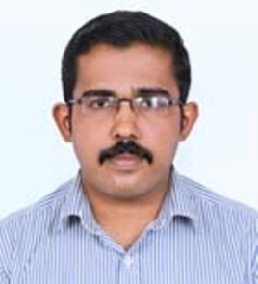
Nirmalyam(H)
Peroor Po,
Kottayam,
Pin -686637
E-Mail : manusn26@gmail.com
Cell No:9526719042

Objective
To work in a challenging environment to explore skills and talents in an organization that offers professional growth while being resourceful and innovative.
Academic profile
Master of Computer Application – M.C.A
[Iindira Gandhi National Open University]

B.A - Economics,
[Baselius college kottayam]

Higher Secondary School
[Govt.Model HigherSecondary School Kottayam]

SSLC
[holy family high school parampuzha Kottayam]

Area of Interests
- Asp.net 3.5,
- C#.net 2008
- Ms-office 2007
Technical Profile
Programming language : Asp.net 3.5,C#.net 2008.
Operating System : Window-7/XP/8.
Data Base : sqlserver 2005.
Web Technologies : HTML

Interest and Hobbies

- Listening Music.
- Watching TV.
- Chat With Friends.

Work Experience

Resource Coordinator.
Pearson India Education Services Private Limited
February 17 -2017 to December-20-2017.
Current ctc-9992

Key Responsibility Areas:

- Maintain the Digitally solution (Hardware/Software etc.) provided by Pearson India Education Services Pvt. Ltd. and ensure maximum uptime at the school.
- Report and follow up all issues immediately to CCC (Customer Care Center) team and his/her immediate reporting manager on the day of occurrence and on day of closure.
- Maintain proper dress code and co-ordinate the necessary activities related to Digitally with school management.
- Assist the teachers to use the solution in the classroom by helping them in resolving their queries with regards to the solution provided by Pearson to facilitate the enhanced Teaching Learning Process.

Personal Profile
Date Of Birth : 11-01-1989
Sex : Male
Nationality : Indian
State : Kerala
Father’s Name : K.K. SomasekharanNair
Mother’s Name : P.E.Leela
Language Known:

- English(Speak&Write)
- Malayalam(Speak&Write)

Competencies
- Hard Worker.
- Organized and well Structured at Work.
- Committed to deadlines and Schedules.
- Honest,Sincere with high level of Intergity

Date: Yours Faithfully,
Place: Kottayam Manu.S.Nair

