CURRICULUM VITAE
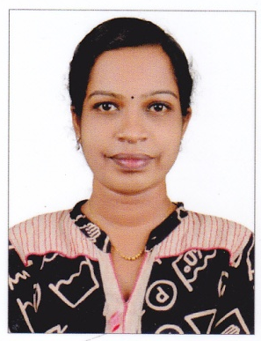
Name : Miss. Karthika .C
Father’s name : Mr.K. Gopakumar
Mother’s name : Mrs. Chithra. R
Date of birth : 15/ 10/ 1992
Age : 25 yrs
Sex : female
Marital status : Single
Nationality : Indian
Religion : Hindu
Caste : OBC
Permanent address : D/o Mr.K. Gopakumar ,Pournami,
Adinadu south, Kattil kadavu (P.O)
Karunagappally, kollam (Dist)
Kerala , Pin - 690542
E-mail address : karthikac177@gmail.com
Contact number : + 919567894917, +919747793564 ,
04762897409

Languages known : Malayalam, English, Malayalam

Hobbies : Reading books, dancing , hearing music

Personal Qualities : communication skills, decision making, situational action , ambitious, positive thinking, under standing

EDUCATIONAL QUALIFICATION
Qualification | University or Board | Name of the institution | Year of pass | percentage
S.S.L.C | Kerala state Board | Govt. higher secondary school  karunagappally | 2008 | 87%
Higher Secondary | Kerala state Board | Govt.F.H.S.S  Kuzhithura | 2010 | 75%
B. Pharm | The Tamil Nadu Dr.M.G.R Medical University, Chennai | Karpagam college of pharmacy  Coimbatore | 2015 | 70%

CONFERENCE ATTENDED
International conference on drug delivery , conducted by Dept. of Biotechnology, New Delhi
Conference on Industry & student interaction , conducted by Indian Pharmaceutical Association& PSG college of Pharmacy, Coimbatore
EXPERIENCE
Working at Ananthapuri hospital & Research institute , Thiruvananthapuram
From 24 -02-2016 to till date
DECLARATION
I hereby declare that the information furnished above is true to the best of my knowledge & belief . I will submit the relevant documents at the time of interview.
Your’s Faithfully,
Place :- Kollam
Date :- KARTHIKA.C

